INSTRUCTION MANUAL:
BC ENERGY COMPLIANCE REPORTS FOR
PART 9 RESIDENTIAL BUILDINGS

FOR ENERGUIDE RATING SYSTEM
ENERGY ADVISORS AND SERVICE ORGANIZATIONS
USING THE 9.36.6 PERFORMANCE PATH

To be used with 2018 BC Building Code Revision 1
(for building permit applications dated December 10, 2018 until December 11, 2019)

Developed with the support of Natural Resources Canada

Latest revision of this manual: October 08, 2020

This page intentionally left blank for double-sided printing
Table of Contents
1 Introduction 3
1.1 The EnerGuide Rating System, Single Family Dwellings, Multi-Unit Residential Buildings, and Attached Ground-Oriented Residential Buildings 3
1.2 2018 BCBC Updates to Step Code Targets for Part 9 Buildings 6
2 Guidelines For Completing BC Energy Compliance Reports Using EnerGuide Rating System 7
3 EnerGuide Rating System 8
4 Step Code Metrics Compliance Calculators and Reports 8
5 Instructions for filling out Pre-construction and As-built Compliance Reports 10
6 Instructions for Modelling Attached Ground-Oriented Part 9 Residential Buildings 24
6.1 Background 24
6.2 Solution 25
APPENDIX I – Sample Step Code Compliance Report 31
APPENDIX II – 2018 BCBC Updates to Step Code Targets for Part 9 Buildings 34
APPENDIX III – Rounding Calculations 43
APPENDIX IV – Manually Calculating Proposed and As-Built House Rated Energy Consumption and Reference House Rated Energy Target 44
APPENDIX V – Manually Calculating Mechanical Energy Use Intensity (MEUI) 47
APPENDIX VI – Manually Calculating ERS Rating % Lower Than EnerGuide Reference House 48
APPENDIX VII – Manually Calculating Thermal Energy Demand Intensity (TEDI) 50
APPENDIX VIII – Manually Calculating Peak Thermal Load (PTL) 51
APPENDIX IX – Manually Calculating % Building’s Conditioned Space Served By Space-Cooling Equipment 53
APPENDIX X – Manually Calculating Energy Source Annual Energy Consumption 55
Appendix XI: List of Modifications to the BCBC 2018 Revision 1 - Step Code Compliance Calculator/Report Generator 59
April 22, 2020 59
October 08,2020 59
Contact Information and Comments 60

Introduction
The BC Energy Step Code (the “Step Code”) is a provincial standard enacted in April 2017 that provides an incremental and consistent approach to achieving more energy efficient buildings that go beyond the requirements of the base BC Building Code (BCBC). It does so by establishing a series of measurable, performance-based energy efficiency requirements for construction that builders can choose to build to, and as of December 15, 2017, communities may voluntarily adopt in bylaws and policies. The Step Code was updated in December 2018. This manual provides a summary of the relevant December 2018 Step Code Updates and a revised set of instructions for utilizing the EnerGuide Rating Systems’ HOT2000 for generating BC Energy Compliance Reports.

The “BC Energy Compliance Reports” (or “Compliance Reports”) provide standardized report templates for Part 9 residential buildings complying with Subsection 9.36.5. or 9.36.6. of the 2018 BC Building Code. The Compliance Reports (one for the Building Permit stage, and one for the Occupancy Permit stage) may be used by:
- EnerGuide Rating System (ERS) Registered Energy Advisors (“Energy Advisors”) and other energy modellers to produce a standardized compliance report;
- Builders to demonstrate that the home/building meets Step Code requirements;
- Local governments to verify builders are complying with a bylaw or policy that references a level of the Step Code; and
- Local governments and utilities to process incentives or rebates that may be aligned with BC Energy Step Code metrics.

The BC Energy Compliance Report - Performance Paths for Part 9 Buildings - Instruction Manual provides:
- General guidelines for using the BC Energy Compliance Report for compliance using the EnerGuide Rating System;
- A table of instructions for completing the BC Energy Compliance Report; and
- Details on how to use HOT2000 to complete the BC Energy Step Code Compliance Calculator, to determine if the building’s performance meets the BC Energy Step Code metrics.

The EnerGuide Rating System, Single Family Dwellings, Multi-Unit Residential Buildings, and Attached Ground-Oriented Residential Buildings
The EnerGuide Rating System Standard version 15.6 describes whether a building is eligible for evaluation under the ERS.

“1.2.1 Eligible housing types
1.2.1.1 Houses
Houses that contain only one dwelling unit, with or without non-residential occupancies, are eligible to be evaluated under the EnerGuide Rating System if they meet the following conditions:
- not greater than three storeys in building height, where building height (in number of storeys) is determined using one of the following methods:
  - in conformity with the National Building Code of Canada 2015;
  - in conformity with the provincial or territorial building code in force;
  - the number of storeys fully above the highest point of finished ground with no more than a combination of four full or partial storeys above the lowest point of finished ground.
- not greater than 600 m² (6458 sq. ft.) in building area;
- are on permanent foundations (this includes a parking garage), or are permanently moored float homes; and
- where a house consists of a mix of residential and non-residential occupancies, where occupancy definitions are those used by the National Building Code of Canada 2015 (i.e. business and personal services, mercantile or low-hazard industrial occupancies):
  - the combined total floor area of the non-residential occupancies is less than that of the residential spaces and does not exceed 300 m² (3229 sq. ft.), excluding parking garages that serve residential occupancies; and
  - the risk category of the non-residential occupancies falls within the acceptable risk categories, as per the EnerGuide Rating System—Technical Procedures Appendix A.
NOTES:
- Row houses and semi-detached houses are to be assessed as houses unless they are comprised of fully or partially stacked units or are joined by a common space, in which case they are to be assessed as a multi-unit residential building.
- Houses with secondary suites are considered multi-unit residential buildings.

1.2.1.2 Multi-unit residential buildings
For a building to be eligible as a MURB under the EnerGuide Rating System, it must meet the requirements in Section 1.2.1.1’s bulleted list and the following conditions:
- contains between two and 100 units;
- dwelling units do not share cooking or sanitary facilities;
- each dwelling unit has a private entrance either from the outside of the building or from a common space (e.g. hallway, lobby, vestibule, or interior stairway) that can be used without passing through another dwelling unit;
- units are fully or partially stacked or joined by a common space;
- secondary suites are fully or partially stacked, side-by-side or joined by a common space; and
- where a building consists of a mix of residential and non-residential occupancies (i.e. business and personal services, mercantile or low-hazard industrial occupancies):
  - the combined total floor area of the non-residential occupancies is less than that of the residential spaces (i.e. areas used for dwelling units and common spaces) and does not exceed 300 m² (3229 sq. ft.), excluding parking garages that serve residential occupancies; and
  - the risk category of the non-residential occupancies falls within the acceptable risk categories, as per the EnerGuide Rating System—Technical Procedures Appendix A.

When the preceding conditions are met, the building can be evaluated as a whole or single-dwelling units can be evaluated individually.
NOTE:
- Houses with secondary suites are considered multi-unit residential buildings.”

The EnerGuide Rating System’s Technical Procedures defines five “house” types and six “Multi-unit Residential Building” types:
- House: single detached; row, end unit; row, middle unit; double/semi-detached; and mobile home; and
- Multi-unit Residential Building: detached duplex; detached triplex; attached duplex; attached triplex; apartment; and apartment row.
The Compliance Calculators for calculating the performance of buildings are contained as two tabs (spreadsheets) in an Excel workbook:
- One tab for houses that are not attached (e.g. single detached and mobile homes) and multi-unit residential buildings (MURBs) as defined by the ERS; and
- One tab for Ground-oriented attached houses that are not considered MURBs under the EnerGuide Rating System (e.g. row houses (end and middle units) and double/semi-detached houses).
The Attached Non-MURB calculator differs from the SFD and MURB Calculator and ERS version 15 procedures in that each unit as per ERS guidelines is first modelled, but then requires that the ERS metrics for each unit be input into the Compliance Calculator for attached-ground oriented Part 9 buildings. The calculator then sums, and where appropriate, averages, the metrics for each unit to achieve the Step Code metrics for the building as a whole. It also takes into consideration the challenge of creating an air barrier between attached units where one is not required by the BC Building Code.

2018 BCBC Updates to Step Code Targets for Part 9 Buildings
On December 10, 2018, Revision 1 to the BC Building Code 2018 created new BC Energy Step Code targets for Part 9 buildings. These changes were implemented to achieve the following objectives:
- Facilitate Step Code compliance for smaller buildings and in colder climates;
- Address issues where large single-family dwellings could comply with Steps 2 or 3 without an improvement over the base BCBC;
- Require the floor area of conditioned space for BC Energy Step Code buildings to be reported to facilitate building officials confirming compliance based on other numbers in the report;
- Facilitate compliance with the Code where cooling is intended for the building; and
- Enable airtightness compliance with the BC Energy Step Code through the EnerGuide Rating System.
The specific changes made to the BC Energy Compliance Report to support the above noted objectives are summarized below, and can be seen in Appendix II:
- Addition of Floor Area of Conditioned Space: Floor area of conditioned space was added to Section A of the Compliance Report to aid building officials in validating the accuracy of the data within the report.
- Removal of Peak Thermal Load (PTL) as a Compliance Metric: PTL was removed as a compliance option in the BC Energy Step Code. Builders may now only use TEDI to demonstrate envelope performance requirements are met. PTL may be provided as supplementary information in Section F of the Compliance Report.
- Revision of Thermal Energy Demand Intensity (TEDI) Targets: TEDI targets were adjusted for all Climate Zones to ensure that all regions in BC have a realistic roadmap to Net Zero Energy Ready, and that levels of effort are more comparable between the Steps in all Climate Zones.
- Revisions of Mechanical Energy Intensity Use (MEUI) Targets:
- Adjusted MEUI Targets for Small Houses: MEUI targets were adjusted for residential buildings 210 m² or less to facilitate Step Code compliance for small houses. This new requirement created staged increases, based on building size and Step, and levels the playing field between larger houses and smaller housing types.
- Adjusted MEUI Targets for All Houses: The MEUI targets were adjusted for all Climate Zones to ensure that all regions in BC have a realistic roadmap to Net Zero Energy Ready and ensure the levels of effort are more comparable between the Steps in all climate zones. This involved changing the targets in the tables of the BC Building Code and adding separate targets for Climate Zones 7A, 7B and 8.
- Adjusted MEUI Target When Cooling is Included in Design: MEUI targets were adjusted where cooling is provided to more than 50% of the floor area of conditioned space. This adjustment is only made when cooling energy consumption is included in the MEUI.

Guidelines For Completing BC Energy Compliance Reports Using EnerGuide Rating System
ITEM | GUIDELINES
Online Access | The BC Energy Compliance Reports can be found online at:  - https://energystepcode.ca/compliance-tools-part9/
BC Energy Compliance Report Versions | As of the date of issue of this manual, there are two versions of the BC Energy Compliance Report:  - VERSION 1.1: Used for building permit applications submitted prior to December 10, 2018, or as required by the Authority Having Jurisdiction (AHJ).  - BCBC 2018 REVISION 1 – EFFECTIVE 2018-12-10: Used for building permit applications submitted on or after December 10, 2018, or as required by AHJ.
Compliance Calculator and Report Generator | - Users of the Compliance Calculator and Report Generator must use recent versions of Microsoft Excel. Legacy versions of Microsoft Excel will not be supported.  - These instructions are designed for individuals using the integrated Microsoft Excel BC Energy Compliance Calculator and Report Generator.
ERS Energy Modelling | Use EnerGuide Rating System Version 15.x, HOT2000 Version 11.x (most recent version). Follow the energy modelling instructions in the most recent versions of the following EnerGuide Rating System documents:  - ERS Administrative Procedures;  - ERS HOT2000 User Guide;  - ERS Technical Procedures; and  - ERS Standard.
Building Types | This version of the manual provides detailed instructions on how to generate the BC Energy Compliance Report for Part 9 residential buildings eligible for evaluation under the ERS as described in Section 1.1 of this Manual. The list aligns with building types that are generally understood by building inspectors.  This drop down does not necessarily use the same nomenclature as HOT2000. A “multi-plex (non-MURB)” as described in Building Types would contain at least three units that share at least two party walls. Each of these units would be defined as “row, middle units” in the “Attached non-MURB Calculator”. A “Row House (non-MURB)” would have at least two units defined as “row, end unit” plus at least one “row, middle unit”
Energy Step Code Regulation | Users of this Instruction Manual and the BC Energy Compliance Report should be familiar and have read within the 2018 BC Building Code:  - Article 2.2.8.2. of Division C, Information Required on Drawings and Specifications;  - Article 2.2.8.3. of Division C, House Performance Compliance Calculation Report;  - Subsection 9.36.5. of Division B, Energy Performance Compliance;  - Subsection 9.36.6. of Division B, Energy Step Code; and  - Information Bulletin No. B18-08: Revisions to the 2018 BC Building Code.
Technical Resources | - Guidelines for Using HOT2000 v.11.x to Demonstrate Compliance with Subsection 9.36.5 of the 2015 National Building Code, Natural Resources Canada

EnerGuide Rating System
Although not a requirement of the British Columbia Building Code, users of the EnerGuide Rating System (ERS) must be Energy Advisors registered and in good standing with Natural Resources Canada in accordance with the EnerGuide Rating System Administrative Procedures and must adhere to the technical standards and procedures of the ERS (as described in BCBC 2018 Note A-9.36.6.4.(2)(b)). Therefore, when using the EnerGuide Rating System for compliance with Subsection 9.36.6. of Division B of the BC Building Code (i.e. the BC Energy Step Code), Energy Advisors must adhere to the energy modelling, site verification, and data collection requirements outlined in the latest version of the following documents:
- ERS Administrative Procedures;
- ERS HOT2000 User Guide;
- ERS Technical Procedures; and
- ERS Standard.

Step Code Metrics Compliance Calculators and Reports
A Microsoft Excel BC Energy Step Code Compliance Calculator workbook with integrated BC Energy Compliance Report Generators is now available to assist EnerGuide Rating System Energy Advisors. Features include:
- Calculator tools to assist with the calculations for the BC Energy Step Code Metrics for Section D and the additional metrics for Section F of the BC Energy Compliance Report. By entering data from the HOT2000 energy model, selecting the project’s Climate Zone, entering cooling system capacity, and the required ‘Step’, these tools calculate the Mechanical Energy Use Intensity (MEUI), ERS Rating % Lower Than EnerGuide Reference House, and Thermal Energy Demand Intensity (TEDI) for Section D, and Other Energy Modelling Metrics for Section F. The calculators also compare the calculated Step Code Metrics to the selected required Step and determine which metrics the building has achieved and the overall result.
- The workbook referred to in bullet 1 above incorporates a report generator for the Pre-Construction and As-Built Compliance Reports. The calculated metrics do not have to be transferred to a separate document (e.g. a PDF version of the Compliance Report). Various other sections of the reports will also auto-populate to save the Energy Advisor time and reduce potential for data entry errors.
Important Notes:
- The calculator is designed for more recent versions of Microsoft Excel. Legacy versions of Excel may not be supported and could impact the functionality of the calculator.
- When using the calculators, or doing manual calculations, ensure the HOT2000 file is set to metric units.
- AHJs may, at their discretion, require evidence that any changes to building design after building permit but before completion does not affect compliance with the Step Code. This may include revisions to the energy model and the pre-construction compliance report.
- Keep the P-file (Pre-Construction) section of the calculator static when updating the As-Built report to keep a record of what had been submitted. In other words, do not update the Proposed House and Proposed Reference House entries in the P-file (Pre-Construction) section of the calculator when doing the As-Built and As-Built Reference House entries.

Instructions for filling out Pre-construction and As-built Compliance Reports
This table of instructions provides a description of what information should be included within each data entry point (field) of the BC Energy Compliance report.

REPORT ITEM | INSTRUCTIONS
A: PROJECT INFROMATION
Building Permit # (if available) | Building Permit Number from the Authority Having Jurisdiction (AHJ, i.e. the Local Government). To be retrieved acquired when available from the AHJ or builder.
 | Data must be entered manually in the Pre-Construction Report; entered data auto-populates in the As-Built Report.
Builder | Full Builder Company Name. In the case of Homeowner Builder, enter Homeowner’s Name.
 | Data must be entered manually in the Pre-Construction Report; entered data auto-populates in the As-Built Report.
Project Address | The address for the project. If no address is available write PENDING.
 | Data must be entered manually in the Pre-Construction Report; entered data auto-populates in the As-Built Report.
Municipality / District | Full name of Jurisdiction of where the building is being constructed, e.g. enter “City of North Vancouver” or “District of North Vancouver”. Confirm with the AHJ or the list of jurisdictions from BC Stats here: http://bit.ly/LocalGovernmentAreasBC to ensure that the Jurisdiction’s name is identified correctly.
 | Data must be entered manually in the Pre-Construction Report; entered data auto-populates in the As-Built Report.
Postal Code | Canada Post Postal Code, if available. If no postal code is available write PENDING.
 | Data must be entered manually in the Pre-Construction Report; entered data auto-populates in the As-Built Report.
PID or Legal Description | The Parcel Identifier (PID) is a nine-digit number that uniquely identifies a parcel in the land title register in BC. Check the BC Land Title and Survey website to find the PID or Legal Description for the property.
 | Data must be entered manually in the Pre-Construction Report; entered data auto-populates in the As-Built Report.
Building Type | Select appropriate type of building from the drop-down menu, e.g. Single-Detached House, rowhouse, etc.  Note: The selection of Building Type determines which calculator will auto-fill the reports. If the building is an attached, non-MURB building (e.g., Double/Semi-detached (non-MURB), Row House (non-MURB), Multi-plex (non-MURB)), the “Attached Non-MURB Calculator” sheet must be used, as the report will seek results from that calculator.
 | Selection must be made manually in the Pre-Construction Report; selection made in the pre-construction report auto-populates in the As-Built Report.
If Other, Please Specify | If the building type is not listed in the drop-down menu, specify what building type it is in the Other field.
 | Data must be entered manually in the Pre-Construction Report; entered data auto-populates in the As-Built Report.
Number of Dwelling Units | Indicate the number of dwelling units in the building. As defined in BCBC, a “dwelling unit means a suite operated as a housekeeping unit, used or intended to be used by one or more persons and usually containing cooking, eating, living, sleeping and sanitary facilities.” (BCBC Division A, Article 1.4.1.2.)
 | Data must be entered manually in the Pre-Construction Report; entered data auto-populates in the As-Built Report.
Climate Zone | BCBC Climate Zone as defined by the Heating Degree-Days of the building’s location or by the AHJ.  Climate Zone Heating Degree-Days  4 < 3000  5 3000 to 3999  6 4000 to 4999  7A 5000 to 5999  7B 6000 to 6999  8 > 6999
 | Input into appropriate calculator. Auto-populates both the Pre-Construction and the As-Built Reports based on calculator input.
Floor Area of Conditioned Space (m²) | Indicate the floor area of conditioned space in square metres. In HOT2000, this is calculated by summing the Above Grade and Below Grade heated floor area found in the Specifications tab.
 | Auto populated in both the pre-construction and as-built reports from the calculator. The calculator requires only the Above Grade and Below Grade Floor Area of Conditioned Space and automatically sums the two, preventing additions errors.
BC Building Code Performance Compliance Path | Select the BC Energy Compliance path the project is following:  - If following the Subsection 9.36.6. Energy Step Code Compliance Path, check the box and complete Sections A, B, D, & E of the BC Energy Compliance Report.  - If following the Subsection 9.36.5. Energy Performance Compliance Path, but NOT complying with Step Code, check the box and complete Sections A, B, C, & E of the BC Energy Compliance Report. (For further guidance, see the Section C guidance below .)  *Many fields in the reports auto-fill from the calculator worksheets. If not using the calculators, some fields will have to be filled out manually after printing.  - If using the Subsection 9.36.5. Energy Performance Compliance Path AND complying with Subsection 9.36.6. Energy Step Code Compliance Path check the box and complete Sections A, B, C, D, & E of the BC Energy Compliance Report. (For further guidance, see the Section C guidance below.)  - For Steps 1 to 5, the ERS Rating % Lower than EnerGuide Reference House is not applicable as the ERS path is not being pursued. Therefore, this line in Section D does not need to be completed. As well, for Steps 2 to 5, do not select an airtightness value in Section C of the Pre-Construction report; the proposed airtightness value should only be included in Section D. For the As Built report, the tested airtightness value should be included in Sections C and D (For further guidance, see the Section C guidance below.)  - Many fields in the reports auto-fill from the calculator worksheets. If not using the calculators, some fields will have to be filled out manually after printing.
 | Data must be entered manually in the Pre-Construction Report; entered data auto-populates in the As-Built Report.
Software Name | List Full Name of Software (e.g. HOT2000) used for energy performance modelling.
 | Data must be entered manually in the Pre-Construction Report; entered data auto-populates in the As-Built Report.
Version | List Version of Software (e.g. v11.6 of HOT2000).
 | Data must be entered manually in the Pre-Construction Report; entered data auto-populates in the As-Built Report.
Climatic Data (Location) | Indicate the Weather location used by the Software. In HOT2000, this can be found in the Weather tab under the Location drop down menu.
 | Data must be entered manually in the Pre-Construction Report; entered data auto-populates in the As-Built Report.
B: BUILDING CHARACTERISTICS SUMMARY:
Autio-fill data can be manually overwritten in AS-Built Report
Details (Assembly / System Type / Fuel Type / Etc.) | Provide a summary of the building characteristics details:  - Provide a summary list as per example in Appendix I. When listing building envelope assemblies, it is a good practice to list the components from outside to inside for walls and top to bottom for ceilings and floors; or  - Indicate information as requested by AHJ.
 | Building Characteristics Summary information entered in the Pre-Construction Report is auto-populated into the As-Built Report. To accommodate changes during construction, the auto populated values can be overwritten in the as-built report.
Effective RSI-Value / Efficiency | Indicate the energy performance of each building characteristic.  - Building Envelope: Indicate the effective RSI-value of the building envelope components from the HOT2000 Tab Separated Values (TSV) file data. Look for the following TSV variables:  - CeilIns – weighted average ceiling effective RSI-value  - MainWallIns – weighted average wall effective RSI-value  - FndWallIns – weighted average effective foundation wall RSI-value  - EGHInExposedFlr – weighted average effective exposed floor RSI-value  Note: the RSI-values from HOT2000 may be different from RSI-values on the architectural drawings.  - Fenestration and Doors: Indicate the range of U-values and SHGC for the windows, skylights, and doors from the energy performance labels.  - HVAC: Indicate the efficiency of the HVAC systems.  - See examples in Appendix I
 | Building Characteristics Summary information entered in the Pre-Construction Report is auto-populated into the As-Built Report. To accommodate changes during construction, the auto populated values can be overwritten in the as-built report.
Exterior Walls & Floor Headers | Describe assembly/construction details of the above grade exterior walls and headers.
Roof / Ceilings | Describe assembly/construction details of the ceilings (attics, cathedral ceilings, etc.).
Foundation Walls, Headers, & Slabs | Describe assembly/construction details of the foundation walls, header and slab.  Also indicate whether the slab is below or above the frost line and whether the slab is heated (e.g. in-floor heating) or not.
Floors over Unheated Spaces | Describe assembly/construction details of the exposed floor(s).
Fenestration and Doors | Describe the type and efficiency characteristics of the fenestration and doors.
FDWR | Enter the ratio of total vertical fenestration and door area to gross wall area as a percentage. This information should be available on the architectural drawings. Note: the FDWR found in the EnerGuide Rating System Results screen includes the area of skylights which should not to be included in the FDWR for BCBC compliance.  For the manual calculation (summarized below), refer to NRCan’s “Guidelines for Using HOT2000 v.11 to Demonstrate Compliance with Subsection 9.36.5 of the 2015 National Building Code.”  - FD: Fenestration and Door Area  - W: Above Grade Gross Wall Area, including headers, above-ground foundation walls and pony walls.  - FDWR (%) = FD/W * 100%
Air Barrier System & Location | Describe the type(s) and location(s) of the air barrier system(s) used.
Space Conditioning (Heating and Cooling) | Describe the type(s) of heating and cooling system(s) used. If a space cooling system is installed but the annual energy consumption of the cooling system is not included in the MEUI metric write: COOLING NOT INCLUDED IN MEUI.
Service Water Heating | Describe the type(s) of domestic hot water heating system(s) used.
Ventilation | Describe the type(s) of ventilation system(s) used.
Other Energy Impacting Features | Describe and indicate other features that may impact the energy performance of the building (e.g. drain water heat recovery unit).
Pre-Construction Confirmation Statement: Based on information provided by the builder, and drawings prepared by: | Indicates the information provided in Section B was sourced from information provided by the builder to the EA or sourced by the EA from the architectural drawings. Provide the name of the firm that completed the architectural drawings and the date it was completed.
As-Built Confirmation Statement: Based on information provided by the builder, and a site evaluation completed on… | Indicates that the information provided in Section B was sourced from information provided by the builder to the EA or was sourced from information collected by the EA at the post-construction site evaluation that was completed according to NRCan ERS procedures. Provide the date of the site visit.

REPORT ITEM | INSTRUCTIONS
C: 9.36.5. ENERGY PERFORMANCE COMPLIANCE
Complete this section if using the Energy Performance Compliance Path in Subsection 9.36.5., for compliance with either of Subsections 9.36.5. or 9.36.6.
If the building is complying with the BC Energy Step Code using Subsection 9.36.5., please complete both Section C and Section D, following the guidance provided under BC Building Code Performance Compliance Path in Section A and reiterated below.
Note: The following guidance applies where HOT2000 is used to model for compliance with Subsection 9.36.5. Those using other software may not be able to apply these instructions to their projects.
Proposed / As-Built House Rated Energy Consumption (GJ/year) | Where using HOT2000 for Subsection 9.36.5. compliance, follow NRCan’s instructions as outlined in the “Guidelines for Using HOT2000 v.11 to Demonstrate Compliance with Subsection 9.36.5 of the 2015 National Building Code” document to obtain the HVAC and Hot Water Heating energy consumption for the Proposed / As-Built House.
Reference House Rated Energy Target (GJ/year) | Where using HOT2000 for Subsection 9.36.5. compliance, follow NRCan’s instructions as outlined in the “Guidelines for Using HOT2000 v.11 to Demonstrate Compliance with Subsection 9.36.5 of the 2015 National Building Code” document to obtain the HVAC and Hot Water Heating energy consumption for the Reference House.
 | The calculator offers an auto-total in the SUM cell.
Airtightness (As-Built Only): | If an airtightness test is done on the As-Built house, indicate the airtightness value as tested, as per BCBC 2018 Division C, Clause 2.2.8.2.(1)(f), “where a test is used to determine the airtightness of a house, the actual measured airtightness of the building envelope in air changes per hour will be reported.”
The airtightness value used in the energy model calculations for the Proposed / As-Built House is: | Indicate the airtightness value used in the energy model for the Proposed / As-Built House by selecting the appropriate option:  - 4.5 ACH @ 50 Pa, where the construction complies with Section 9.25.,  - 3.5 ACH @ 50 Pa, where it can be shown that the air barrier system is constructed in accordance with Subsection 9.25.3 and Articles 9.36.2.9. and 9.36.2.10., or  - Tested in accordance with Sentence 9.36.5.10.(11) of Division B (only an option for the As-Built house).  Note: If complying with Step 2 or above of Subsection 9.36.6. using Subsection 9.36.5., the airtightness value being used in the proposed house need not be entered in the Pre-Construction Report. This should be added in Section D.  For more details, see BCBC Sentence 9.36.5.10.(9) of Division B.
Confirmation Statement: The above calculation was performed in compliance with Subsection 9.36.5. of Division B | Check to confirm Section C of the Compliance Report is completed in compliance with Subsection 9.36.5. of Division B.
D: 9.36.6. ENERGY STEP CODE COMPLIANCE
Complete this section if complying with Subsection 9.36.6.
Note: the guidance provided applies to the completion of the BC Energy Compliance Reports using HOT2000 and the EnerGuide Rating System for modelling. Those using other software may not be able to apply these instructions to their projects.
The metrics itemized in this section are auto-populated in the BC Energy Compliance Reports from the appropriate calculator.
It is critical to use the correct calculator tab in the in the workbook titled “BC Step Code Compliance Calculator Report” to calculate the metrics. The lowercase word “calculator” is intended to refer to both the general calculator and the attached ground-oriented non-MURB residential building calculator
* For instructions on how to model ground-oriented attached Part 9 residential buildings (e.g. row houses, duplexes, triplexes, etc.) that are NOT considered MURBs by the ERS use the instructions in the next section titled “Instructions for Modelling Attached Ground-Oriented Part 9 Residential Buildings”
Proposed House / As-Built House Rated Energy Consumption (GJ/year) | Annual energy consumption of the Proposed / As-Built House without baseloads. Equivalent to ‘Total AEC’ minus ‘Baseloads’ from the HOT2000 calculation results, rounded to the nearest whole number. See Appendix IV for manual calculation details where to locate data in HOT2000.
 | Input HOT2000 data in calculator. Auto-populates in Pre-Construction and As-Built Report based on Calculator Results
Reference House Rated Energy Target (GJ/year) | Annual energy consumption of the Reference House without baseloads. Equivalent to ‘ERS reference house-Base Case’ minus ‘Baseloads’ from the HOT2000 calculation results, rounded to the nearest whole number. See Appendix IV for manual calculation details and where to locate data in HOT2000.
 | Input HOT2000 data in calculator. Auto-populates in Pre-Construction and As-Built Report based on Calculator Results
Step Code Level | Indicates the Step Code level the project is required to meet, as set by the AHJ.
 | Select Step Level in calculator. Auto-populates in Pre-Construction and As-Built Report based on Calculator Results
Mechanical Energy Use Intensity (MEUI) | The MEUI in Section D is automatically calculated after input of HOT2000 data and Climate and Cooling Information into the calculator.  Required: The compliance requirement as per BCBC 2018 Article 9.36.6.3. of Division B.  Proposed: Use the Proposed House energy model, see instructions for manual calculations and where to locate data in HOT2000 in Appendix V.  As-Built: Use the As-Built energy model, see instructions for manual calculations and where to locate data in HOT2000 in Appendix V.  For Determining: % of the Building’s Conditioned Space Served by Space-Cooling Equipment, see instructions in Appendix IX.
 | Input HOT2000 Data in calculator. Auto-populates in Pre-Construction and As-Built Report based on Calculator Results
ERS Rating % Lower Than EnerGuide Reference House, where applicable | This info in Section D is automatically calculated for buildings that have complied following the ERS, after HOT2000 data is entered into the calculator.  Required: The compliance requirement as per BCBC 2018 Article 9.36.6.3. of Division B.  Proposed: Use the Proposed House energy model, see instructions for manual calculations and where to locate data in HOT2000 in Appendix VI.  As-Built: Use the As-Built energy model, see instructions for manual calculations and where to locate data in HOT2000 in Appendix VI.  Note: If not using the ERS to comply with the Step Code, this section need not be completed. Compliance when not using ERS is demonstrated by meeting the metrics for Steps 2 and above.
 | Input HOT2000 data in calculator. Auto-populates in Pre-Construction and As-Built Report based on Calculator Results
Thermal Energy Demand Intensity (TEDI) | This info in Section D is automatically calculated after input of HOT2000 data in calculator.  Required: The compliance requirement as per BCBC 2018 Article 9.36.6.3. of Division B.  Proposed: Use the Proposed House energy model, see instructions for manual calculations and where to locate data in HOT2000 in Appendix VII.  As-Built: Use the As-Built energy model, see instructions for manual calculations and where to locate data in HOT2000 in Appendix VII.
 | Input HOT2000 Data in calculator. Auto-populates in Pre-Construction and As-Built Report based on Calculator Results
Airtightness in Air Changes per Hour at 50 Pa differential | This info in Section D is automatically calculated after input of HOT2000 data in calculator.  Required: The compliance requirement as per BCBC 2018 Article 9.36.6.3. of Division B.  Proposed: Enter compliance requirement per BCBC Article 9.36.6.3. of Division B OR other lower airtightness target as identified by the Energy Advisor.  As-Built: Enter actual blower door test result from the final site evaluation.
 | HOT2000 Input Data in calculator. Auto-populates in Pre-Construction and As-Built Report based on Calculator Results
Step Code [Design] Requirements Met | Check Yes or No if the home met, or did not meet, the requirement for the prescribed Step Code level.
 | Auto-populates in Pre-Construction and As-Built Report based on Calculator Results
Confirmation Statement: The above calculation was performed in compliance with (see Clause 2.2.8.3.(2)(e) of Division C) | Check the appropriate compliance calculation method used (i.e.:  - Subsection 9.36.5.,  - The Passive House Planning Package (PHPP), version 9 or newer, and the energy model was prepared by a Certified Passive House Designer or Certified Passive House Consultant,  - The EnerGuide Rating System (ERS), version 15 or newer, or  - The applicable requirements of NECB Part 8 and the City of Vancouver Energy Modelling Guidelines.
E: COMPLETED BY
Full Name (Print) | Print first and last name of Registered Energy Advisor.
Company Name | Enter Energy Advisor’s full company name.
Phone | Enter Energy Advisor’s business phone number.
Address | Enter Energy Advisor’s business company address.
Email | Enter Energy Advisor’s business email address.
Date (dd/mm/yyyy) | Enter the date when the BC Energy Compliance Report was completed.
Advisor ID Number | Enter Energy Advisor’s identification number issued by the Service Organization.
Service Organization | Enter the name of the Service Organization where the file was submitted.
EnerGuide P / N # | Enter the full EnerGuide Rating System P file and/or N file number.
Calculator Instruction: “E: COMPLETED BY” information that is manually entered by the Energy Advisor in the Pre-Construction Report is auto-populated in the As-Built Report. If the ‘Completed By’ information changes, the data can be overwritten by the completing Energy Advisor.
F: OTHER ENERGY MODELLING METRICS
Airtightness NLA@10Pa | Reference House: Use the Proposed House ERS Reference House for the Pre-Construction Compliance Report or the As-Built ERS Reference House for the As-Built Compliance Report. Taken from Full House Report’s “Air Leakage and Mechanical Ventilation” section. Reported in cm²/m², rounded to the hundredth’s decimal (two decimal places).  Proposed: Taken from the Proposed House energy model’s Full House Report from the “House with standard operating conditions” run “Air Leakage and Mechanical Ventilation” section or from the Homeowner Information Sheet. Reported in cm²/m², rounded to the hundredths decimal (two decimal places).  As-Built: Taken from the As-Built House energy model’s Full House Report from the “House with standard operating conditions” run “Air Leakage and Mechanical Ventilation” section or from the Homeowner Information Sheet. Reported in cm²/m², rounded to the hundredths decimal (two decimal places).
 | Input HOT2000 Data in calculator. Auto-populates in Pre-Construction and As-Built Report based on Calculator Results
Rated Greenhouse Gas Emissions | Reference House: Use the Proposed House ERS Reference House for the Pre-Construction Compliance Report or the As-Built ERS Reference House for the As-Built Compliance Report. Take ‘Estimated Greenhouse Gas Emissions’ from the Full House Report from the “Reference House” run, and multiply by 1000 kg/t to get kg/year, rounded to the nearest whole number.  Proposed: Take ‘Estimated Greenhouse Gas Emissions’ from Proposed House energy model Full House Report from the “House with standard operating conditions” run, multiplied by 1000 kg/t to get kg/year, rounded to the nearest whole number.  As-Built: Take ‘Estimated Greenhouse Gas Emissions’ from As-Built House energy model Full House Report from the “House with standard operating conditions” run, multiplied by 1000 kg/t to get kg/year, rounded to the nearest whole number.
 | Input HOT2000 Data in calculator. Auto-populates in Pre-Construction and As-Built Report based on Calculator Results
Rated Greenhouse Gas Intensity | Reference House: Use the Proposed House ERS Reference House for the Pre-Construction Compliance Report or the As-Built ERS Reference House for the As-Built Compliance Report. Take the ‘Estimated Greenhouse Gas Emissions’ from Full House Report from the “Reference House” run. Divide the Estimated Greenhouse Gas Emissions by the total heated floor area and multiply by 1000 kg/t to get kg/m²/year, rounded to the hundredth’s decimal (two decimal places).  Proposed: Take the ‘Estimated Greenhouse Gas Emissions’ from Proposed House energy model’s Full House Report from the “House with operating conditions” run. Divide the Estimated Greenhouse Gas Emissions by the total heated floor area and multiply by 1000kg/t to get kg/m²/year, rounded to the hundredths decimal (two decimal places).  As-Built: Take the ‘Estimated Greenhouse Gas Emissions’ from As-Built House energy model’s Full House Report from the “House with operating conditions” run. Divide the Estimated Greenhouse Gas Emissions by the total heated floor area and multiply by 1000 kg/t to get kg/m²/year, rounded to the hundredths (two) decimal.
 | Input HOT2000 Data in calculator. Auto-populates in Pre-Construction and As-Built Report based on Calculator Results
Rated Energy Use Intensity | Reference House: Use the Proposed House ERS Reference House for the Pre-Construction Compliance Report or the As-Built ERS Reference House for the As-Built Compliance Report. ‘ERS Reference House (GJ/year)’ taken from the HOT2000 calculation results divided by Total Floor Area of Conditioned Space. Reported in GJ/m²/year, entered to the hundredths (two) decimal.  Proposed: ‘Energy Use Intensity’ taken from the Proposed House energy model HOT2000 calculation results divided by Total Floor Area of Conditioned Space. Reported in GJ/m²/year, entered to the hundredths (two) decimal.  As-Built: ‘Energy Use Intensity’ taken from the As-Built House energy model HOT2000 calculation results divided by Total Floor Area of Conditioned Space. Reported in GJ/m²/year, entered to the hundredths (two) decimal.
 | Input HOT2000 Data in calculator. Auto-populates in Pre-Construction and As-Built Report based on Calculator Results
Peak Thermal Load (PTL) | Reference House: Use the Proposed House ERS Reference House for the Pre-Construction Compliance Report or the As-Built ERS Reference House for the As-Built Compliance Report, see instructions in Appendix VIII.  Proposed: Use the Proposed House energy model, see instructions for manual calculations and where to locate data in HOT2000 in Appendix VIII.  As-Built: Use the As-Built energy model, see instructions for manual calculations and where to locate data in HOT2000 in Appendix VIII.
 | Input HOT2000 Data in calculator. Auto-populates in Pre-Construction and As-Built Report based on Calculator Results
% of the Building’s Conditioned Space Served by Space-Cooling Equipment | Enter “Not more than 50%” if the HOT2000 energy model does not have the cooling energy consumption included in the annual energy consumption (i.e. cooling energy is not included in ERS GJ rating), even if there is cooling installed in the home that is modelled as an atypical load.  If the HOT2000 energy model does have the cooling energy consumption included in the annual energy consumption (i.e. cooling energy is included in the ERS GJ rating):  - Enter “Not more than 50%” if the cooling system’s capacity is not more than 50% of the Design Cooling Load.  - Enter “More than 50%” if the cooling system’s capacity is more than 50% of the Design Cooling Load.  See instructions in Appendix IX.
 | Input HOT2000 Data in calculator. Auto-populates in Pre-Construction and As-Built Report based on Calculator Results
% Lower than Reference House With Baseloads Included | Enter the ‘% Lower (Higher) Than Ref House’ from the EnerGuide Rating System Results screen. This metric can only be used if the file is completed by a registered ERS energy advisor using ERS modelling procedures and the file is submitted to the Service Organization and Natural Resources Canada.
 | Input HOT2000 Data in calculator. Auto-populates in Pre-Construction and As-Built Report based on Calculator Results
Energy Source | Enter the annual consumption of the various energy sources used by the home in GJ. See instructions in Appendix X.
 | Input HOT2000 Data in calculator. Auto-populates in Pre-Construction and As-Built Report based on Calculator Results
Electricity Consumption | Reference House: Enter Reference House electricity consumption, see instructions in Appendix X.  Proposed: Use the Proposed House energy model, see instructions in Appendix X.  As-Built: Use the As-Built energy model, see instructions in Appendix X.
 | Input HOT2000 Data in calculator. Auto-populates in Pre-Construction and As-Built Report based on Calculator Results
Natural Gas Consumption | Reference House: Enter Reference House natural gas consumption, see instructions in Appendix X.  Proposed: Use the Proposed House energy model, see instructions in Appendix X.  As-Built: Use the As-Built energy model, see instructions in Appendix X.
 | Input HOT2000 Data in calculator. Auto-populates in Pre-Construction and As-Built Report based on Calculator Results
Propane Consumption | Reference House: Enter Reference House propane consumption, see instructions in Appendix X.  Proposed: Use the Proposed House energy model, see instructions in Appendix X.  As-Built: Use the As-Built energy model, see instructions in Appendix X.
 | Input HOT2000 Data in calculator. Auto-populates in Pre-Construction and As-Built Report based on Calculator Results
District Energy Consumption | The process to determine the annual district energy consumption is yet to be determined.
 | Input HOT2000 Data in calculator. Auto-populates in Pre-Construction and As-Built Report based on Calculator Results
On-Site Renewables Consumption | This field refers to the amount of energy generated from on-site renewable sources that offset the total energy consumption of the home.  Reference House: Enter “N/A” or “-” as On-site Renewables is not included in the EnerGuide Rating System Reference House.  Proposed: Use the Proposed House energy model, see instructions in Appendix X.  As-Built: Use the As-Built energy model, see instructions in Appendix X.
 | Input HOT2000 Data in calculator. Auto-populates in Pre-Construction and As-Built Report based on Calculator Results
Other | Only enter the annual consumption in GJ of other energy sources that are included in the total energy consumption of the energy model. For example:  - If a wood burning stove is present but “Usage” is set to “Never” in HOT2000, do not enter the energy consumption for the wood.  - If a wood burning stove is present and “Usage” is set to “Always” in HOT2000, enter the energy consumption for the wood.  Reference House: Enter annual consumption of other energy sources in GJ. The energy consumption of other sources is available in the Reference House Full House Report under “Estimated Annual Fuel Consumption Summary.” Convert these to GJ. See Appendix X for more information.  - If completing the Pre-Construction Compliance Report, use the Reference House Full House Report from the Proposed House energy model.  - If completing the As-Built Compliance Report, use the Reference House Full House Report from the As-Built energy model.  Proposed: Use the Proposed House energy model, see instructions in Appendix X.  As-Built: Use the As-Built energy model, see instructions in Appendix X.
 | Input HOT2000 Data in calculator. Auto-populates in Pre-Construction and As-Built Report based on Calculator Results
Total Consumption | Sum the Electricity, Natural Gas, Propane, District Energy, and Other energy consumption and subtract the On-Site Renewables and enter it into the respective Total field for the Reference House, Proposed House, and As-Built house.  - i.e. Electricity (GJ) plus Natural Gas (GJ) plus Propane (GJ) plus District Energy (GJ) plus Other (GJ) minus On-Site Renewables (GJ)
 | Input HOT2000 Data in calculator. Auto-populates in Pre-Construction and As-Built Report based on Calculator Results
G: OPTIONAL CERTIFICATIONS
Pending - Labelling Programs | If there is a pending energy labelling certification, check the appropriate box and, if applicable, indicate the appropriate level of the certification (e.g. Built Green, Level: Gold).

Instructions for Modelling Attached Ground-Oriented Part 9 Residential Buildings
NOTE:
- These procedures provide guidance and instruction on how to model non-MURB, Attached Ground-Oriented Part 9 Residential Buildings for the BC Energy Step Code and on how to use the Attached Non-MURB Calculator spreadsheet tab found in the BCBC 9.36.6 Compliance Calculator workbook.
- These procedures do NOT apply to Attached Ground-Oriented Part 9 Residential Buildings defined by the EnerGuide Rating System as MURBs. The EnerGuide Rating System defines Attached Ground-Oriented Buildings with any vertical overlap of any unit over another unit as a MURB.
- Non-MURB Attached Ground-Oriented Part 9 Residential Buildings include all Part 9 residential buildings with 2 or more units where no units have any vertical overlap: for example, double/semi-detached buildings, triplexes, quadplexes, etc. and row houses.
- The “Attached Non-MURB Calculator” differs from the first Compliance Calculator and ERS version 15 procedures in that each unit as per ERS guidelines is first modelled, but then requires that the ERS metrics for each unit be input into the Calculator for Attached Ground-Oriented Part 9 buildings. The calculator then sums, and where appropriate, averages, the metrics for each unit to achieve the Step Code metrics for the building as a whole. It takes into consideration the challenge of creating an air barrier between attached units, where one is not required by the BC Building Code.
- If manually calculating the Step Code metrics, please also refer to Appendices I through X in this manual.

Background
Among the 1,586 buildings in BC that were modelled using the ERS in 2017, the median air changes per hour at 50 Pascals pressure differential (ACH₅₀) was:
Table 1. Median airtightness results for energy assessments across BC in 2017
Type of Building | Number of Assessments | Median Airtightness (ACH50)
Single Detached | 1160 | 3.49
Double/Semi-detached | 109 | 3.69
Row house, end unit | 122 | 4.11
Row house, middle unit | 193 | 4.72
Total | 1586 | 3.81
There is a difference in air leakage for attached buildings compared to air leakage for detached buildings. Detached buildings, by default, leak to the exterior. Air leakage between attached buildings can be to both conditioned space (a neighbouring unit) and unconditioned space (the exterior). The temperature gradients between two conditioned zones are far less than the temperature gradient between the building and the exterior.
While there are builders who can construct attached units and achieve the airtightness goals of the BC Energy Step Code, requiring each unit to meet an airtightness target would require a new Code requirement, as the Code addresses buildings and not individual units.
This solution is intended for buildings that are seeking to comply with the Lower Steps of the BC Energy Step Code (i.e., Steps 1, 2 and 3). The correction is available only down to 1.5 ACH.

Solution
The goal of this section is to document a consistent approach on reporting on the energy performance of attached ground-oriented Part 9 dwelling units divided by vertical party walls with no stacking, i.e. attached buildings that are not considered MURBs in the ERS Technical Procedures.
The Technical Procedures of the ERS has definitions for several “house” types – single detached; row, end unit; row, middle unit; double/semi-detached; and mobile home. For row and semi-detached to qualify to be modelled as a single unit, there must be at least one vertical division (known as a party wall), with no stacking of units. If there is even a small amount of stacking or if attached units are joined by a common space, the building must go through the ERS multi-unit residential building (MURB) processes.
The ERS defines a “row, middle unit” as “A dwelling unit separated by at least two vertical divisions termed “party walls”, from the adjacent dwelling units.” This selection should be made in HOT2000 for any units in triplexes, quadplexes or multiplexes with more than one neighbouring unit.
Under the Specifications tab, HOT2000 also includes three more house types: duplex (non-MURB), triplex (non-MURB), and apartment (non-MURB). They are not listed in the ERS Technical Procedures version 15.6 and are not to be used in HOT2000 for the purposes of the Attached Non-MURB Calculator.
- Create the energy models:
  - P file: Create a P-file for Unit 1 in HOT2000 Version 11.6 or newer as per ERS guidelines. Under Natural Air Infiltration Specifications, use:
    - select Blower Door Test Values and enter a value based on the Building and Safety Standards Branch (BSSB) Information Bulletin No. B19-03 guidance on selecting airtightness of proposed building; or
    - 4.55 ACH₅₀; or
    - select Blower Door Test Values and input the highest of the builder's last 5 Blower door tests (See ERS User Guide Version 11.6 section 7.13.1).
  - N file: Create an N file for Unit 1 in HOT2000 Version 11.6 or newer as per ERS guidelines using the results of the blower door test.
- Adjust the ACH:

NOTE: If a multi-zone blower door test is planned at the P file stage and/or performed at the N file stage DO NOT adjust the ACH. Go to bullet 3 below.

IMPORTANT: Because of the information outlined in Section 6.1, Energy Advisors are permitted to use a 0.5 ACH₅₀ adjustment for attached ground units where the airtightness test values are as low as 2.00 ACH₅₀. This enables, for example an energy advisor to input 2.00 – 0.50 = 1.50 ACH₅₀. Below 2.00 ACH₅₀ until 1.50 ACH₅₀, the Energy Advisor may use a value of 1.50 ACH_{50.} Below 1.50 ACH₅₀, the Energy Advisor must use the ACH₅₀ value as tested.
If performing single-zone blower door tests on each unit, create a Save-As file. Name the Save-AS file with the N or P file 10 character string as per ERS guidelines---i.e. SOEA(N or P)XXXXX where SO is the Service Organization number, EA the Energy Advisors # with the SO, and XXXXX the file number of the respective P/N file that will be submitted to NRCan. Close the save-as file.
Open the original file and name it the same as the save-as file, plus “-SC”: ie. SOEA(N or P)XXXXX-SC. Using this file, do the following:
- P file: Under Natural Air Ventilation/Specifications/“Air Tightness Type”, select “Blower Door test Values” and input as follows:
    - Enter into the Air Change Rate field, a value as guided by following “Guidelines for Energy Advisors – Setting Airtightness Values….”; Information Bulletin No. B19-03; Building and Safety Standards Branch, minus 0.5 ACH₅₀ for results that are 2.00 ACH₅₀ or greater. Below 2.00 ACH₅₀ until 1.50 ACH₅₀, the Energy Advisor may use a value of 1.50 ACH_{50.} Below 1.50 ACH₅₀, the Energy Advisor must use the ACH₅₀ value as tested; or
    - Set the “Equivalent Leakage Area” to calculated.

- N file: Under Natural Air Ventilation/Specifications/“Air Tightness Type”, select “Blower Door test Values” and input into the Air Change Rate field:
- Input into the Air Change Rate field the resulting ACH from the blower door test minus 0.5 ACH.
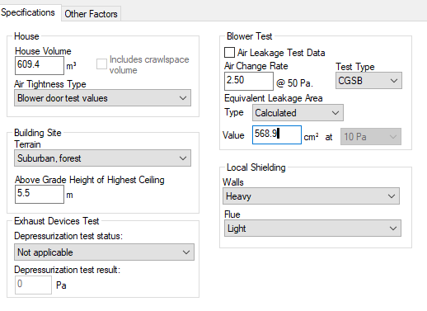
- Set the “Equivalent Leakage Area” to calculated.
- Input into the Attached Non-MURB Calculator, outputs from the HOT2000 file as follows:
Ensure units are in metric (Select Edit Change Units Units & Mode Display Units Metric).
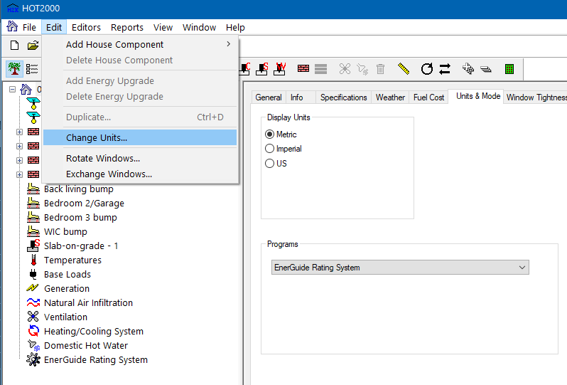
Use the outputs from the respective P or N file from bullet 1 above, where a multi zone test is planned or performed OR from the respective “SAVE AS” P or N file from bullet 2 above where a multi zone test is NOT planned or performed.
  - For each unit, select the unit type (row, end unit; row, middle unit; or double/semi-detached). Extract from the appropriate HOT2000 model and enter into the excel Step Code Compliance workbook’s Attached Non-MURB Calculator spreadsheet, the unit’s Floor Area (see Appendix V for where to find floor area), and the ACH used from the appropriate file. The Floor Area and Building Envelope Surface Area will be the same for the Proposed and Reference cases. The ACH for the reference house is already entered in the calculator.
Note:
  - As per ERS guidelines, takeoffs for Volume and Floor Area are to be the interior side of the Party Walls for each unit.

  - Perform a calculation (“Reports/Calculate” or Alt+C) on the P or N file, and Select the Base tab on the dialogue box. In the Excel Step Code Compliance Attached Non-MURB Calculator spreadsheet tab:
- enter the Total AEC for the Proposed House into its field in the Unit 1 row.
- enter the ERS Reference House Net (GJ/a) for the Reference House into its respective field in the Unit 1 row in the calculation spreadsheet.

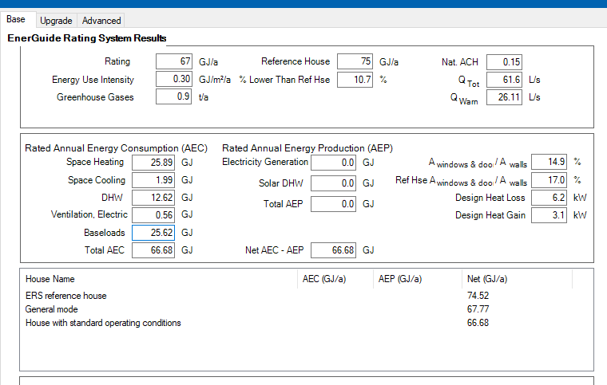

- In HOT2000, open the Full Report/House with Standard Operating Conditions for the proposed house:
    - Go to the Air Leakage and Mechanical Ventilation area. Enter the Building Envelope Surface Area in m² and the Normalized Leakage Area @ 10 Pa into their respective fields in the Unit 1 row in the calculation spreadsheet.
Note:
- The Building Envelope Surface Area does NOT include Party Wall areas.
- DO NOT manually sum the areas from the summary view.

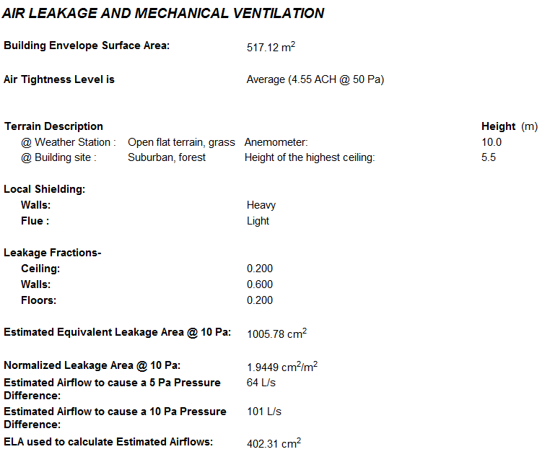

- Go to the Annual Space Heating Summary. Enter the Auxiliary Energy Required in MJ into its respective field in the Unit 1 row in the calculation spreadsheet.

- Go to the Design Space Heating and Cooling Loads area. Enter the Design Heat Loss and the Design Cooling Load in Watts into their respective fields in the Unit 1 row in the calculation spreadsheet.

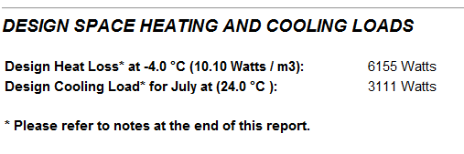
- Go to the Air Conditioning System area. Enter the Capacity in Watts into its field in the Unit 1 row in the calculation spreadsheet.

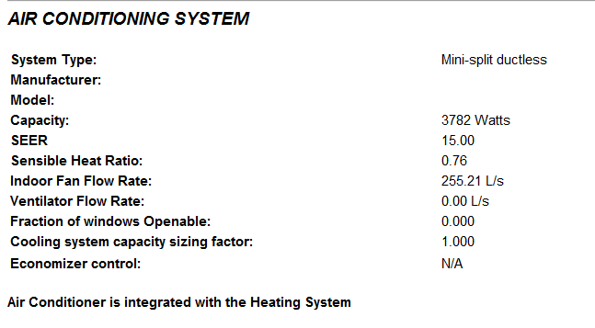
- When required by the AHJ, go to the Energy Consumption Report and the Estimated Annual Fuel Consumption Report and enter into the respective rows in columns J through P in the Attached Non-MURB Calculator spreadsheet the GHGs, fuel consumption (Electricity, Natural Gas, etc.), On-site renewables, and Other (for example wood). (See the screenshot in 3) c) above).
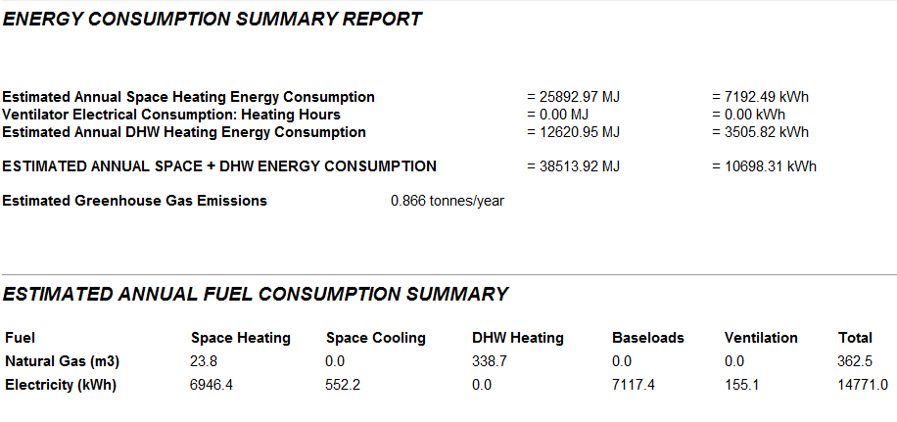
- In HOT2000, open the Full Report for the reference house and:
- Go to the Air Leakage and Mechanical Ventilation area. Enter the Normalized Leakage Area @ 10 Pa into its respective field in the Unit 1 row in the calculation spreadsheet. (See the screenshot in 3) c) above).
- Go to the Annual Space Heating Summary. Enter the Auxiliary Energy Required in MJ into its respective field in the Unit 1 row in the calculation spreadsheet. (See the screenshot in 3) c) above).
- Go to the Design Space Heating and Cooling Loads area. Enter the Design Heat Loss in Watts into their respective fields in the Unit 1 row in the calculation spreadsheet. (See the screenshot in 3) c) above).
- When required by the AHJ, go to the Energy Consumption Report and the Estimated Annual Fuel Consumption Report and enter into the respective rows in columns labelled M through R in the Attached Non-MURB Calculator spreadsheet the GHGs, fuel consumption (Electricity, Natural Gas, etc.), On-site renewables, and Other (for example wood). (See the screenshot in 3) c) above). Save the HOT2000 file.
- Create a new HOT2000 file for each townhome unit and repeat steps 1 to 5 for each unit.
- When all units have been modeled and the data has been entered into the excel Step Code Compliance workbook, go to the Attached Non-MURB Calculator spreadsheet. This spreadsheet automatically calculates the building’s overall MEUI, %LTRH, TEDI, and ACH. The results are found in column L, rows 41 to 44 for the proposed (pre-construction) house and rows 52 to 55 for the as-built house. These results are auto-filled into section D of the respective “Pre-construction” and “As-Built” report tabs. In rows 60 to 74 in the Attached Non-MURB Calculator tab you will find the information that auto-fills section E of the respective “Pre-construction” and “As-Built” report tabs
- Fill out the remaining information required in the Pre-construction or As Built Report, print the applicable report to PDF and submit to the builder, or the AHJ, or both as necessary. Note – the Energy Advisor must also submit the HOT2000 N file to the AHJ, demonstrating that the air changes per hour reported in the As Built calculator and report is no more than 0.5 ACH₅₀ lower than the air changes per hour in the N file.

More Details on Calculations
- Air Changes per Hour:
$$The {ACH}_{50} for the building=\frac{\left({ACH}_{50,1}×{SA}_{1}\right)+\left({ACH}_{50,2}×{SA}_{2}\right)+⋯+\left({ACH}_{50,n}×{SA}_{n}\right)}{{SA}_{total}}$$
Where:
n = # of TH units;
SA = Exterior building envelope Surface Area (does NOT include party wall areas). This value is found in the full report “Air Leakage and Mechanical Ventilation” area.
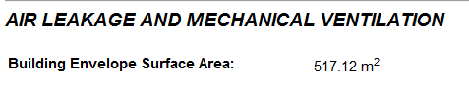
- All the individual unit outputs entered into the Attached Non-MURB Calculator spreadsheet as per the instructions above are summed for each category (i.e. Space Heating system Load, AEC, etc.) to generate building totals. These building totals are used to calculate the step code metrics for %LTRH, MEUI, and TEDI for the building as a whole.

APPENDIX I – Sample Step Code Compliance Report
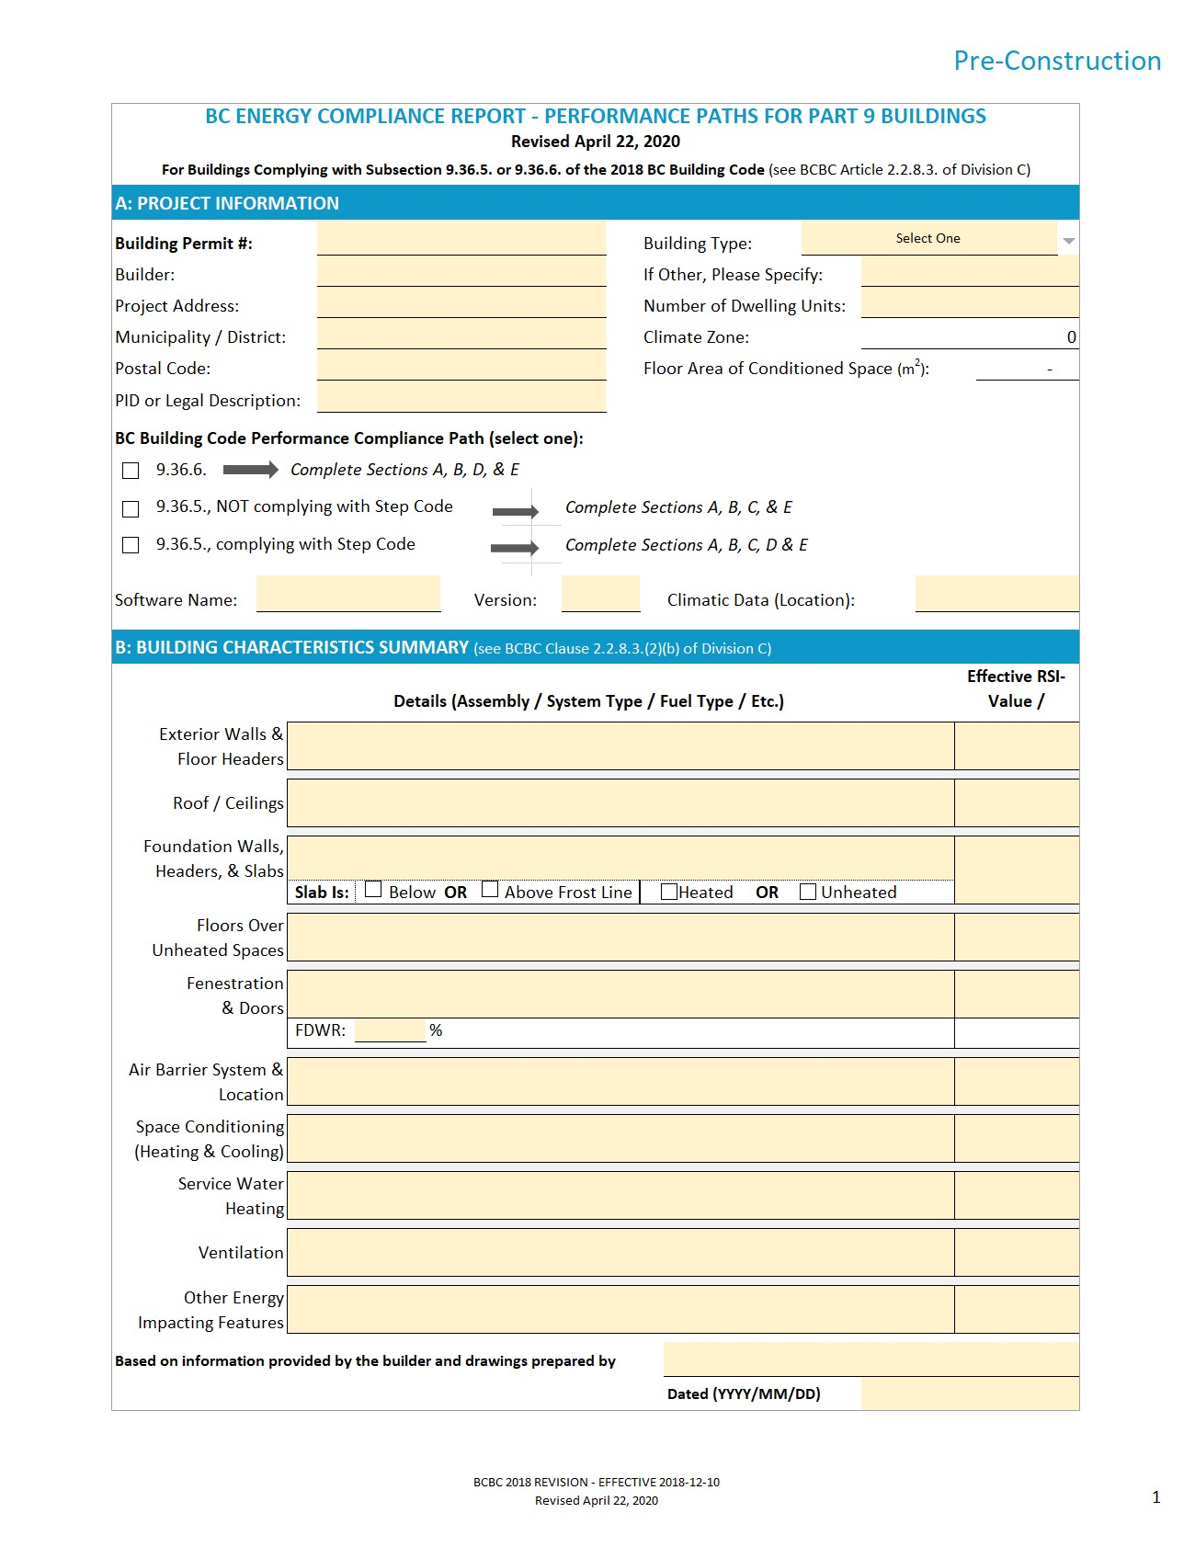

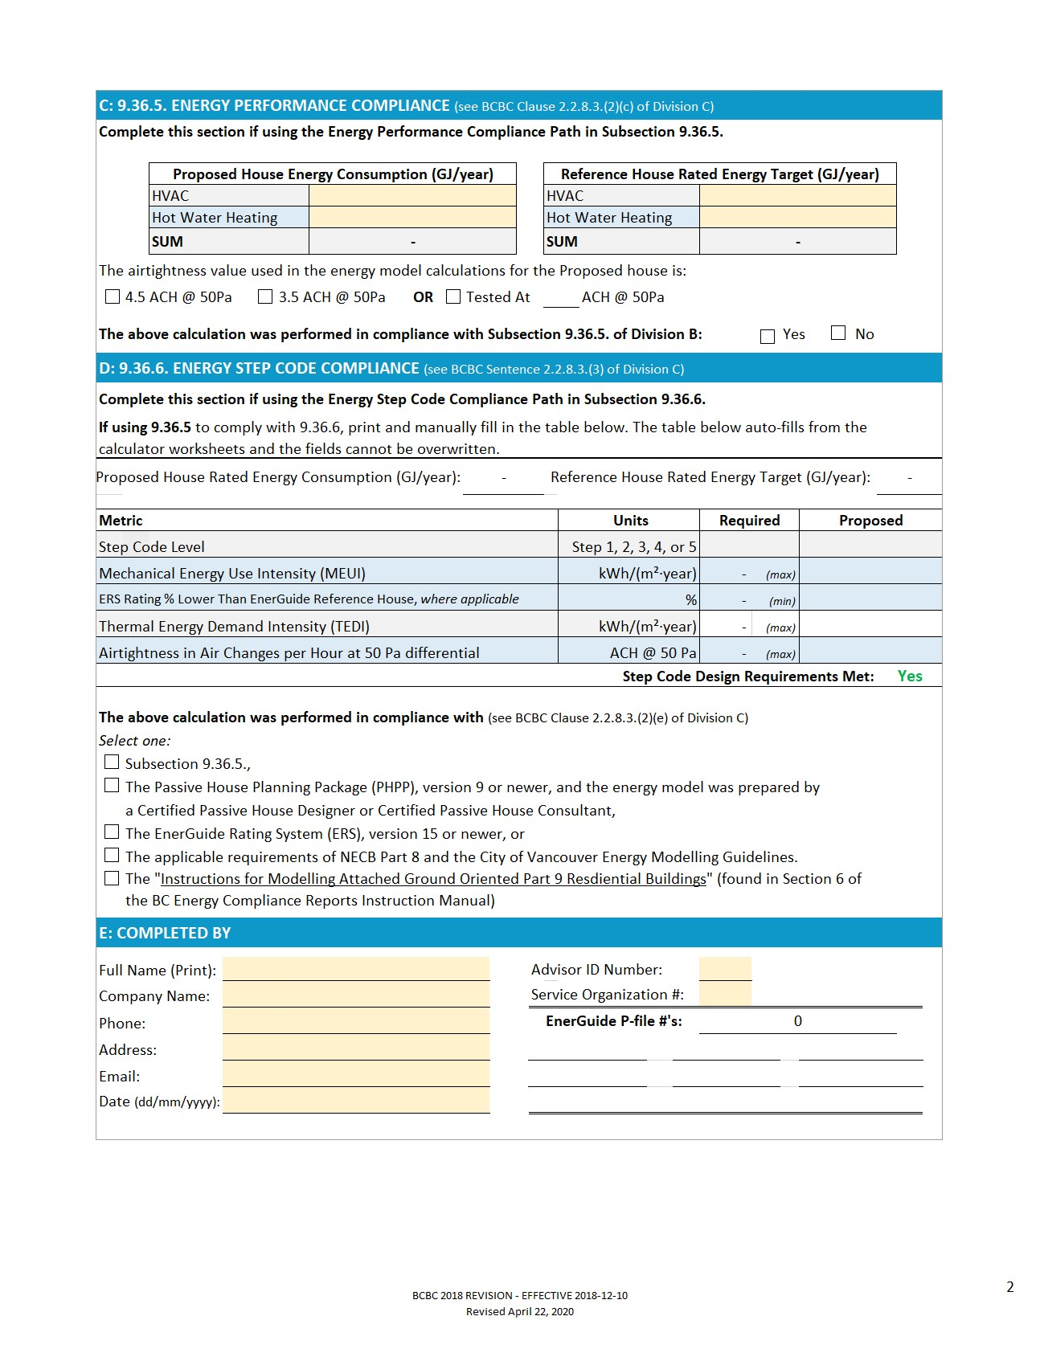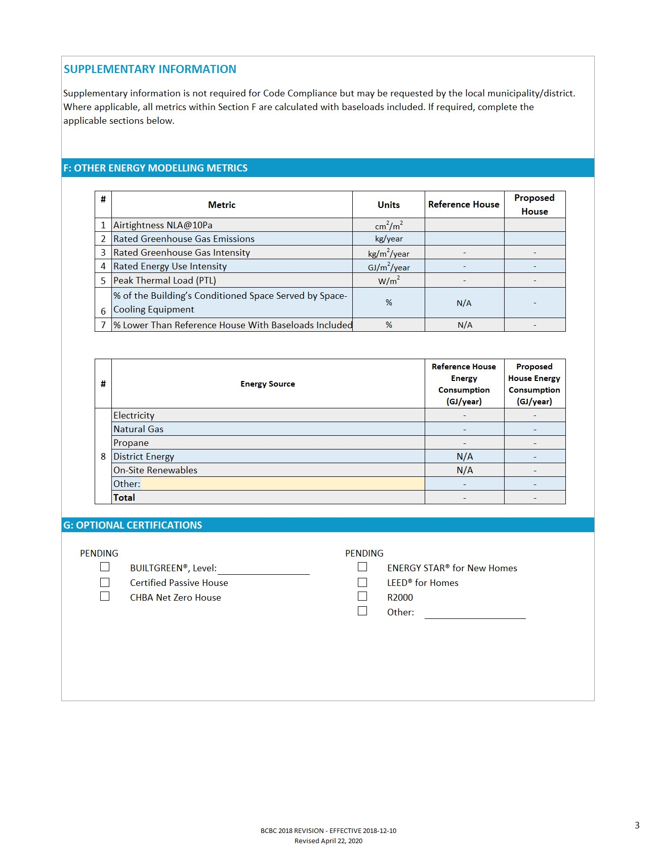

APPENDIX II – 2018 BCBC Updates to Step Code Targets for Part 9 Buildings
Revisions to the BCBC became effective on December 10, 2018. This Appendix details the changes including rationales to the BCBC that are related to the BC Energy Step Code compliance targets for Part 9 buildings. Tables outlining the current Step Code metric targets can be found at the end of this Appendix. The following summary updates are taken from the Building and Safety Standards Branch Information Bulletin No. B18 – 08, and other communications from the Building and Safety Standards Branch.
Update 1: Removed Peak Thermal Load as Compliance Metric
The 2012 BCBC allowed builders following the BC Energy Step Code to use either PTL or TEDI to demonstrate compliance with the BC Energy Step Code envelope performance requirements. In some cases, complying using PTL would result in significantly worse energy performance than would be achieved by complying with TEDI.
PTL was removed as a compliance option in the BC Energy Step Code. Builders may now only use TEDI to demonstrate envelope performance requirements are met. PTL may be provided voluntarily as supplementary information in Section F of the Compliance Report.
Rationale:
PTL may provide an excessive relaxation for some builders in some climates, allowing for lower levels of performance than complying with TEDI. TEDI is an adequate measure for improving envelope performance. PTL as an additional compliance option is unnecessary and may lead to inconsistent outcomes compared to TEDI.
BCBC 2018 compliance must be achieved by meeting the TEDI target, and will enable buildings to demonstrate the desired improvement in energy performance expected from the BC Energy Step Code.
Update 2: Adjusted TEDI Targets in All Climate Zones
TEDI targets were adjusted for all Climate Zones to ensure that all regions in BC have a realistic roadmap to Net Zero Energy Ready, and that levels of effort are more comparable between the Steps in all Climate Zones. Under the 2012 BCBC, builders working in cold climates would have difficulty meeting both the MEUI and the TEDI targets, especially at the upper steps. On the other hand, for Steps 2 and 3, large single-detached dwellings in Climate Zones 5 and 6 would potentially consume more energy than those built to the minimum requirements of the BCBC.
These updates lead to more reasonable costs in the north, and modest increases in cost with better energy savings in warmer climates for lower Steps. They also ensure that each Step will achieve energy savings more consistently with what each Step was set out to achieve, i.e. 10%, 20% and 40% for Steps 2, 3 and 4, respectively.
Rationale:
The BCBC 2012 did not include any climate-specific TEDI targets for Climate Zones 7A, 7B and 8, making Step Code less applicable for those regions. Additionally, for some Steps in warmer Climate Zones, the BCBC 2018 targets ensure an improved level of building energy performance than the prescriptive Building Code. With the changes to TEDI, the level of effort and cost associated with moving up the Steps will be more equitable between Climate Zones, and performance at each Step will achieve energy savings more consistent with what each Step was set out to achieve, i.e. 10%, 20% and 40% for Steps 2, 3 and 4, respectively.
Update 3: Adjusted MEUI Targets
3a: Adjusted MEUI Targets for Small Houses
Staged increases were created, based on building size and step, to the MEUI for small buildings. House Size was added as a variable that increased the number of baseline MEUI targets.
Rationale:
Builders of small houses, such as small lot houses, laneway houses, coach houses, and row houses, found the BCBC 2012 MEUI requirements difficult to achieve cost-effectively. This placed smaller houses at a disadvantage over larger ones, and some local governments set lower Step requirements for smaller houses. Domestic hot water consumption, which is part of MEUI, has the same total modelled energy consumption for a single family house in ERS, regardless of house size. As a result, the energy intensity of the domestic hot water load is much greater for small houses, making it more difficult to achieve the target for smaller homes. This created an unfair situation for small, often more affordable houses that consume less overall energy. Creating an adjustment of MEUI levels the playing field between larger houses and smaller housing types.
3b: Adjusted MEUI Targets for All Houses
The base MEUI targets in all climate zones have been adjusted to increase the likelihood that MEUI outcomes are closer to the expected 10%, 20% and 40% energy efficiency improvements in Steps 2 through 4, to make MEUI targets more achievable in colder regions of BC, and to ensure that all regions in BC have a realistic roadmap to Net Zero Energy Ready. This involved changing the target numbers in the tables of the BC Building Code and adding three additional tables for Climate Zones 7A, 7B and 8.
Rationale:
The BCBC 2012 MEUI targets did not include specific targets for Climate Zones 7A, 7B and 8, making the Step Code more difficult to meet in those climate zones. For Steps 2 and 3, large single-detached dwellings in Climate Zones 5 and 6 could potentially consume more energy than those built to the minimum requirements of the BCBC when a MEUI target rather than the % lower than EnerGuide Reference House target was used for compliance with building equipment and systems performance requirements.
3c: Provided MEUI Target Adjustment When Cooling is Included in Design
The BCBC 2012 did not address cooling, putting buildings with cooling at a disadvantage compared to buildings that do not include cooling. This disadvantage was notable in regions with higher July design temperatures. MEUI includes cooling energy consumption; however, the BCBC 2012 target did not change whether a house was modelled with a cooling system or not. Where cooling is provided to more than 50% of the floor area of conditioned space, MEUI targets were adjusted. These adjustments are staged as buildings become smaller.
Rationale:
Addressing the need for cooling and adjusting the MEUI targets accordingly ensures that efficient houses are comfortable and healthy. The new targets enable builders to provide energy efficient cooling where it is necessary and still comply with the MEUI target.

BCBC 2018 Step Code Metric Targets (as of Revision 1)
Table 9.36.6.3.-A
Requirements for Buildings Located Where the Heating Degree-Days Below 18°C Value is less than 3000
Forming Part of Sentence 9.36.6.3.(1)
Step | Airtightness (Air Changes per Hour at 50 Pa Pressure Differential) | Performance Requirement of Building Equipment and Systems | Performance Requirement of Building Envelope
1 | N/A | EnerGuide Rating % lower than EnerGuide Reference House: not less than 0% lower energy consumption  or  conform to Subsection 9.36.5.
2 | ≤3.0 | EnerGuide Rating % lower than EnerGuide Reference House: not less than 10% lower energy consumption  or  the applicable mechanical energy use intensity requirements in Table 9.36.6.3.-G | Thermal energy demand intensity ≤35 kWh/(m²·year)
3 | ≤2.5 | EnerGuide Rating % lower than EnerGuide Reference House: not less than 20% lower energy consumption  or  the applicable mechanical energy use intensity requirements in Table 9.36.6.3.-G | Thermal energy demand intensity ≤30 kWh/(m²·year)
4 | ≤1.5 | EnerGuide Rating % lower than EnerGuide Reference House: not less than 40% lower energy consumption  or  the applicable mechanical energy use intensity requirements in Table 9.36.6.3.-G | Thermal energy demand intensity ≤20 kWh/(m²·year)
5 | ≤1.0 | The applicable mechanical energy use intensity requirements in Table 9.36.6.3.-G | Thermal energy demand intensity ≤15 kWh/(m²·year)

Table 9.36.6.3.-B
Requirements for Buildings Located Where the Heating Degree-Days Below 18°C Value is 3000 to 3999
Forming Part of Sentence 9.36.6.3.(1)
Step | Airtightness (Air Changes per Hour at 50 Pa Pressure Differential) | Performance Requirement of Building Equipment and Systems | Performance Requirement of Building Envelope
1 | N/A | EnerGuide Rating % lower than EnerGuide Reference House: not less than 0% lower energy consumption  or  conform to Subsection 9.36.5.
2 | ≤3.0 | EnerGuide Rating % lower than EnerGuide Reference House: not less than 10% lower energy consumption  or  the applicable mechanical energy use intensity requirements in Table 9.36.6.3.-G | Thermal energy demand intensity ≤45 kWh/(m²·year)
3 | ≤2.5 | EnerGuide Rating % lower than EnerGuide Reference House: not less than 20% lower energy consumption  or  the applicable mechanical energy use intensity requirements in Table 9.36.6.3.-G | Thermal energy demand intensity ≤40 kWh/(m²·year)
4 | ≤1.5 | EnerGuide Rating % lower than EnerGuide Reference House: not less than 40% lower energy consumption  or  the applicable mechanical energy use intensity requirements in Table 9.36.6.3.-G | Thermal energy demand intensity ≤30 kWh/(m²·year)
5 | ≤1.0 | The applicable mechanical energy use intensity requirements in Table 9.36.6.3.-G | Thermal energy demand intensity ≤20 kWh/(m²·year)

Table 9.36.6.3.-C
Requirements for Buildings Located Where the Heating Degree-Days Below 18°C Value is 4000 to 4999
Forming Part of Sentence 9.36.6.3.(1)
Step | Airtightness (Air Changes per Hour at 50 Pa Pressure Differential) | Performance Requirement of Building Equipment and Systems | Performance Requirement of Building Envelope
1 | N/A | EnerGuide Rating % lower than EnerGuide Reference House: not less than 0% lower energy consumption  or  conform to Subsection 9.36.5.
2 | ≤3.0 | EnerGuide Rating % lower than EnerGuide Reference House: not less than 10% lower energy consumption  or  the applicable mechanical energy use intensity requirements in Table 9.36.6.3.-G | Thermal energy demand intensity ≤60 kWh/(m²·year)
3 | ≤2.5 | EnerGuide Rating % lower than EnerGuide Reference House: not less than 20% lower energy consumption  or  the applicable mechanical energy use intensity requirements in Table 9.36.6.3.-G | Thermal energy demand intensity ≤50 kWh/(m²·year)
4 | ≤1.5 | EnerGuide Rating % lower than EnerGuide Reference House: not less than 40% lower energy consumption  or  the applicable mechanical energy use intensity requirements in Table 9.36.6.3.-G | Thermal energy demand intensity  ≤40 kWh/(m²·year)
5 | ≤1.0 | The applicable mechanical energy use intensity requirements in Table 9.36.6.3.-G | Thermal energy demand intensity  ≤25 kWh/(m²·year)

Table 9.36.6.3.-D
Requirements for Buildings Located Where the Heating Degree-Days Below 18°C Value is 5000 to 5999
Forming Part of Sentence 9.36.6.3.(1)
Step | Airtightness (Air Changes per Hour at 50 Pa Pressure Differential) | Performance Requirement of Building Equipment and Systems | Performance Requirement of Building Envelope
1 | N/A | EnerGuide Rating % lower than EnerGuide Reference House: not less than 0% lower energy consumption  or  conform to Subsection 9.36.5.
2 | ≤3.0 | EnerGuide Rating % lower than EnerGuide Reference House: not less than 10% lower energy consumption  or  the applicable mechanical energy use intensity requirements in Table 9.36.6.3.-G | Thermal energy demand intensity  ≤80 kWh/(m²·year)
3 | ≤2.5 | EnerGuide Rating % lower than EnerGuide Reference House: not less than 20% lower energy consumption  or  the applicable mechanical energy use intensity requirements in Table 9.36.6.3.-G | Thermal energy demand intensity ≤70 kWh/(m²·year)
4 | ≤1.5 | EnerGuide Rating % lower than EnerGuide Reference House: not less than 40% lower energy consumption  or  the applicable mechanical energy use intensity requirements in Table 9.36.6.3.-G | Thermal energy demand intensity  ≤55 kWh/(m²·year)
5 | ≤1.0 | The applicable mechanical energy use intensity requirements in Table 9.36.6.3.-G | Thermal energy demand intensity  ≤35 kWh/(m²·year)

Table 9.36.6.3.-E
Requirements for Buildings Located Where the Heating Degree-Days Below 18°C Value 6000 to 6999
Forming Part of Sentence 9.36.6.3.(1)
Step | Airtightness (Air Changes per Hour at 50 Pa Pressure Differential) | Performance Requirement of Building Equipment and Systems | Performance Requirement of Building Envelope
1 | N/A | EnerGuide Rating % lower than EnerGuide Reference House: not less than 0% lower energy consumption  or  conform to Subsection 9.36.5.
2 | ≤3.0 | EnerGuide Rating % lower than EnerGuide Reference House: not less than 10% lower energy consumption  or  the applicable mechanical energy use intensity requirements in Table 9.36.6.3.-G | Thermal energy demand intensity  ≤100 kWh/(m²·year)
3 | ≤2.5 | EnerGuide Rating % lower than EnerGuide Reference House: not less than 20% lower energy consumption  or  the applicable mechanical energy use intensity requirements in Table 9.36.6.3.-G | Thermal energy demand intensity ≤90 kWh/(m²·year)
4 | ≤1.5 | EnerGuide Rating % lower than EnerGuide Reference House: not less than 40% lower energy consumption  or  the applicable mechanical energy use intensity requirements in Table 9.36.6.3.-G | Thermal energy demand intensity  ≤65 kWh/(m²·year)
5 | ≤1.0 | The applicable mechanical energy use intensity requirements in Table 9.36.6.3.-G | Thermal energy demand intensity  ≤50 kWh/(m²·year)

Table 9.36.6.3.-F
Requirements for Buildings Located Where the Heating Degree-Days Below 18°C Value is greater than 6999
Forming Part of Sentence 9.36.6.3.(1)
Step | Airtightness (Air Changes per Hour at 50 Pa Pressure Differential) | Performance Requirement of Building Equipment and Systems | Performance Requirement of Building Envelope
1 | N/A | EnerGuide Rating % lower than EnerGuide Reference House: not less than 0% lower energy consumption  or  conform to Subsection 9.36.5.
2 | ≤3.0 | EnerGuide Rating % lower than EnerGuide Reference House: not less than 10% lower energy consumption  or  the applicable mechanical energy use intensity requirements in Table 9.36.6.3.-G | Thermal energy demand intensity  ≤120 kWh/(m²·year)
3 | ≤2.5 | EnerGuide Rating % lower than EnerGuide Reference House: not less than 20% lower energy consumption  or  the applicable mechanical energy use intensity requirements in Table 9.36.6.3.-G | Thermal energy demand intensity  ≤105 kWh/(m²·year)
4 | ≤1.5 | EnerGuide Rating % lower than EnerGuide Reference House: not less than 40% lower energy consumption  or  the applicable mechanical energy use intensity requirements in Table 9.36.6.3.-G | Thermal energy demand intensity  ≤80 kWh/(m²·year)
5 | ≤1.0 | The applicable mechanical energy use intensity requirements in Table 9.36.6.3.-G | Thermal energy demand intensity  ≤60 kWh/(m²·year)

Table 9.36.6.3.-G Mechanical Energy Use Intensity Requirements
Forming Part of Sentence 9.36.6.3.(1)
Heating Degree-Days of Building Location in Celsius Degree-Days | Amount of the Building’s Conditioned Space Served by Space-Cooling Equipment | Step | Floor Area of Conditioned Space (m²)
 |  |  | ≤50 | 51 to 75 | 76 to 120 | 121 to 165 | 166 to 120 | >210
 |  |  | Mechanical Energy Use Intensity, kWh/ (m²·year)
Less than 3000 | Not more than 50% | 2 | 135 | 120 | 90 | 75 | 65 | 60
 |  | 3 | 120 | 100 | 75 | 63 | 53 | 50
 |  | 4 | 90 | 80 | 60 | 48 | 40 | 40
 |  | 5 | 65 | 55 | 40 | 30 | 25 | 25
 | More than 50% | 2 | 170 | 148 | 108 | 85 | 73 | 65
 |  | 3 | 155 | 128 | 93 | 73 | 60 | 55
 |  | 4 | 125 | 108 | 78 | 58 | 48 | 45
 |  | 5 | 100 | 83 | 58 | 40 | 33 | 30
3000 to 3999 | Not more than 50% | 2 | 145 | 130 | 100 | 85 | 75 | 70
 |  | 3 | 135 | 115 | 90 | 78 | 68 | 65
 |  | 4 | 100 | 90 | 70 | 58 | 50 | 50
 |  | 5 | 70 | 60 | 45 | 35 | 30 | 30
 | More than 50% | 2 | 180 | 158 | 118 | 95 | 83 | 75
 |  | 3 | 170 | 143 | 108 | 88 | 75 | 70
 |  | 4 | 135 | 118 | 88 | 68 | 58 | 55
 |  | 5 | 105 | 88 | 63 | 45 | 38 | 35
4000 to 4999 | Not more than 50% | 2 | 160 | 145 | 115 | 100 | 90 | 85
 |  | 3 | 145 | 125 | 100 | 88 | 78 | 75
 |  | 4 | 105 | 95 | 75 | 63 | 55 | 55
 |  | 5 | 80 | 70 | 55 | 45 | 40 | 40
 | More than 50% | 2 | 195 | 173 | 133 | 110 | 98 | 90
 |  | 3 | 180 | 153 | 118 | 98 | 85 | 80
 |  | 4 | 140 | 123 | 93 | 73 | 63 | 60
 |  | 5 | 115 | 98 | 73 | 55 | 48 | 45
5000 to 5999 | Not more than 50% | 2 | 185 | 170 | 140 | 125 | 115 | 110
 |  | 3 | 165 | 145 | 120 | 108 | 98 | 95
 |  | 4 | 120 | 110 | 90 | 78 | 70 | 70
 |  | 5 | 95 | 85 | 70 | 60 | 55 | 55
 | More than 50% | 2 | 220 | 198 | 158 | 135 | 123 | 115
 |  | 3 | 200 | 173 | 138 | 118 | 105 | 100
 |  | 4 | 155 | 138 | 108 | 88 | 78 | 75
 |  | 5 | 130 | 113 | 88 | 70 | 63 | 60
6000 to 6999 | Not more than 50% | 2 | 205 | 190 | 160 | 145 | 135 | 130
 |  | 3 | 185 | 165 | 140 | 128 | 118 | 115
 |  | 4 | 135 | 125 | 105 | 93 | 85 | 85
 |  | 5 | 105 | 95 | 80 | 70 | 65 | 65
 | More than 50% | 2 | 240 | 218 | 178 | 155 | 143 | 135
 |  | 3 | 220 | 193 | 158 | 138 | 125 | 120
 |  | 4 | 170 | 153 | 123 | 103 | 93 | 90
 |  | 5 | 140 | 123 | 98 | 80 | 73 | 70
More than 6999 | Not more than 50% | 2 | 225 | 210 | 180 | 165 | 155 | 150
 |  | 3 | 200 | 180 | 155 | 143 | 133 | 130
 |  | 4 | 150 | 140 | 120 | 108 | 100 | 100
 |  | 5 | 115 | 105 | 90 | 80 | 75 | 75
 | More than 50% | 2 | 260 | 238 | 198 | 175 | 163 | 155
 |  | 3 | 235 | 208 | 173 | 153 | 140 | 135
 |  | 4 | 185 | 168 | 138 | 118 | 108 | 105
 |  | 5 | 150 | 133 | 108 | 90 | 83 | 80

APPENDIX III – Rounding Calculations
To ensure consistency among Energy Advisors, below are guidelines for rounding when performing calculations to obtain the Step Code Metrics from HOT2000 and for the BC Energy Compliance Report:

- When pulling information from HOT2000 and making calculations (through the Energy Step Code Compliance Calculator or by hand) enter all values, whenever possible, to the hundredth decimal place (2 numbers after the decimal).
- When entering Proposed or As-Built House Rated Energy Consumption, Reference House Rated Energy Target, TEDI, and MEUI calculation results into Section D of the BC Energy Compliance Report, round the results to the nearest whole number (i.e. no decimal places). This means that:
  - If the tenth decimal is less than 5, round down (e.g. 26.49 is rounded down to 26).
  - If the tenth decimal is equal to or greater than 5, round up (e.g. 26.51 is rounded up to 27).
- When entering ERS % Lower Than Reference House and Airtightness in Air Changes Per Hour at 50 Pa into Section D of the BC Energy Compliance Report, round the results to the tenth decimal place (i.e. one decimal place). This means that:
  - If the hundredth decimal is less than 5, round down (e.g. 26.51 is rounded down to 26.5).
  - If the hundredth decimal is equal to or greater than 5, round up (e.g. 26.49 is rounded up to 26.5). Similarly, 26.95 is rounded up to 27.0.

APPENDIX IV – Manually Calculating Proposed and As-Built House Rated Energy Consumption and Reference House Rated Energy Target
Proposed and As-Built House Rated Energy Consumption without baseloads in GJ/year
Reference House Rated Energy Target without baseloads in GJ/year

- Definition:
  - The Proposed or As-Built House Rated Energy Consumption describes the energy use over a year without baseloads, expressed in GJ/year.
  - The Reference House Rated Energy Target describes the energy use over a year without baseloads if the home was built to the National Building Code, expressed in GJ/year.

- Formula:
  - Proposed or As-Built House Rated Energy Consumption (GJ) = Total Annual Energy Consumption of the House (GJ) – Baseloads (GJ)
  - Reference House Rated Energy Target (GJ) = Total Annual Energy Consumption of the Reference House (GJ) – Baseloads (GJ)

- HOT2000 Screenshots are provided for manual calculations. For the Excel Compliance Calculator HOT2000 Inputs, see HOT2000 Tab.

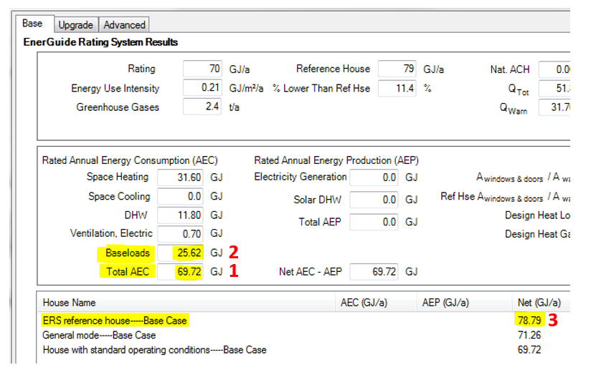

  - Total AEC (GJ) = Total Annual Energy Consumption of the House.
  - Baseloads (GJ) = Annual Baseload consumption based on ERS Standard Operating Conditions.
  - ERS reference house--Base Case (GJ) = Total Annual Energy Consumption of the Reference House.

Important Note: Do not take the values from the Advanced tab as those have already been rounded to the tenth decimal, which may give a higher or lower result if it is rounded further.

- Example Calculation:
- Proposed or As-Built House Rated Energy Consumption = 1 – 2
  - Proposed or As-Built House Rated Energy Consumption = 69.72 GJ minus 25.62 GJ = 44.10 GJ; and rounded down to 44 GJ/year.
- Reference House Rated Energy Target = 3 – 2
  - Reference House Rated Energy Target = 78.79 GJ minus 25.62 GJ = 53.17 GJ; and rounded down to 53 GJ/year.

APPENDIX V – Manually Calculating Mechanical Energy Use Intensity (MEUI)
Mechanical Energy Use Intensity (MEUI) in kWh/(m²·year)

- Definition: MEUI describes the mechanical energy use over a year, estimated by using an energy model in accordance with BCBC Article 9.36.6.4., normalized per square metre of area of conditioned space and expressed in kWh/(m²·year). Mechanical equipment included in the MEUI are space-heating, space-cooling, fans, service water heating equipment, pumps, and auxiliary HVAC equipment.
- Formula: MEUI (kWh/(m²·year)) = (Total Annual Energy Consumption (kWh/year) – Baseloads (kWh/year)) / Heated Floor Area (m²)
- HOT2000 Screenshots are provided for manual calculations. For the Excel Compliance Calculator HOT2000 Inputs, see HOT2000 Tab.
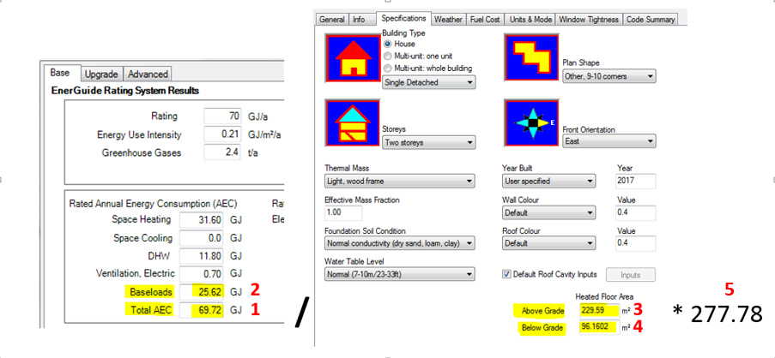
  - Total AEC (GJ) = Total Annual Energy Consumption of the House.
  - Baseloads (GJ) = Annual Baseload consumption based on ERS Standard Operating Conditions.
  - Above Grade Heated Floor Area (m²) = The sum of all floor areas that are located on a floor level that is entirely above grade.
  - Below Grade Heated Floor Area (m²) = The sum of all basement floor areas that are located on a floor level that is wholly or partially below grade.
  - Energy conversion where 277.78 kWh = 1 GJ

- Example Calculation:
  - MEUI = [(1 minus 2) / (3 + 4)] * 5
  - MEUI = [(69.72 GJ minus 25.62 GJ) divided by (229.59 m² plus 96.16 m²)] multiplied by 277.78 kWh/GJ = 37.61 kWh/(m²·year); rounded up to 38 kWh/(m²·year)

APPENDIX VI – Manually Calculating ERS Rating % Lower Than EnerGuide Reference House
EnerGuide Rating System (ERS) Rating Compared to ERS Reference House without baseloads (%LTRH w/o BL) in percentage (%).

- Definition: Percentage Lower Than Reference House without baseloads (%LTRH w/o BL) is a result of comparing the energy consumption of the proposed building to an automatically-generated ERS reference house from HOT2000 version 11.x (latest version). The metric does not include the ERS assumed electric base loads.

- Formula: %LTRH w/o BL (%) = 100 – ((Total Energy Consumption Proposed House (kWh/year) – Baseloads (kWh/year)) x 100 / (Total Energy Consumption Reference House (kWh/year) – Baseloads (kWh/year)))

- HOT2000 Screenshots are provided for manual calculations. For the Excel Compliance Calculator HOT2000 Inputs, see HOT2000 Tab.
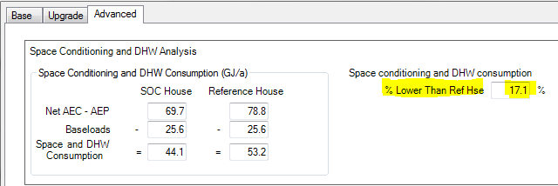
After modelling the house run the calculations by pressing Alt + C. The %LTRH w/o BL can be found on the right hand side of the third tab labelled “Advanced.”

- For Manual Calculations: The needed figures are taken from the first tab labelled “Base” instead of the space heating and DHW figures form the third “Advanced” tab for increased accuracy.

- Total AEC (GJ) = Total Annual Energy Consumption of the House.
- Baseloads (GJ) = Annual Baseload consumption based on ERS Standard Operating Conditions.
- ERS reference house-Base Case (GJ) = Total Annual Energy Consumption of the Reference House.

- Example Calculation:
  - %LTRH w/o BL = 100 – ((1 – 2) * 100 / (3 – 2))
  - %LTRH w/o BL = 100 – ((69.72 GJ minus 25.6 GJ) multiplied by 100 divided by (78.79 GJ minus 25.62 GJ)) = 17.05%; rounded to 17.1%

APPENDIX VII – Manually Calculating Thermal Energy Demand Intensity (TEDI)
Thermal Energy Demand Intensity (TEDI) in kWh/(m²·year)

- Definition: TEDI describes the annual heating required by the building for space conditioning and for conditioning of ventilation air, estimated by using an energy model in accordance with BCBC Article 9.36.6.4., normalized per square metre of area of conditioned space and expressed in kWh/(m²·year). TEDI considers thermal transmittance of the building envelope components (including assemblies, windows, doors and skylights), air leakage through the air barrier system, internal heat gains from occupants and equipment, and heat recovery from exhaust ventilation.
- Formula: TEDI (kWh/(m²·year)) = Space Heating Demand (kWh/year) / Heated Floor Area (m²)
- HOT2000 Screenshots are provided for manual calculations. For the Excel Compliance Calculator HOT2000 Inputs, see HOT2000 Tab.
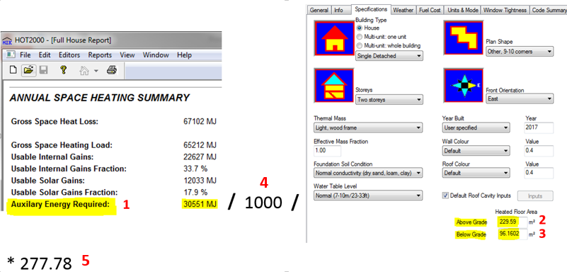
- Auxiliary Energy Required (MJ) = The amount of heat energy the space heating equipment must provide to maintain the house temperatures. Obtained from the Full House Report using data from the “House with standard operating conditions” run.
- Above Grade Heated Floor Area (m²) = The sum of all floor areas that are located on a floor level that is entirely above grade.
- Below Grade Heated Floor Area (m²) = The sum of all basement floor areas that are located on a floor level that is wholly or partially below grade.
- Energy conversion where 1000 MJ = 1 GJ
- Energy conversion where 277.78 kWh = 1 GJ

- Example Calculation:
  - TEDI = 1 / 4 / (2 + 3) * 5
  - TEDI = 30,551MJ divided by 1000MJ/GJ divided by (229.59m² plus 96.16m²) multiplied by 277.78kWh/GJ = 26.05kWh/(m²·year); rounded down to 26kWh/(m²·year)

APPENDIX VIII – Manually Calculating Peak Thermal Load (PTL)
Peak Thermal Load (PTL) in W/m²
- Definition: While Peak Thermal Load (PTL) is no longer a formal reporting metric requirement for the BC Energy Step Code, it is listed on the supplementary information in Section F of the BC Energy Compliance Report, and may be required as an administrative requirement by some Authorities Having Jurisdiction. PTL describes the maximum heating energy required by the building for space conditioning and for conditioning of ventilation air, estimated by using an energy model at a 2.5% January design temperature and expressed in watts per square metre of area (W/m²) of conditioned space. PTL considers the same factors as TEDI, which are thermal transmittance of the building envelope components (including assemblies, windows, doors and skylights), air leakage through the air barrier system, internal heat gains from occupants and equipment, and heat recovery from exhaust ventilation.

- Formula: PTL (W/m²) = Design Heat Loss (W) / Heated Floor Area (m²)

- HOT2000 Screenshots are provided for manual calculations. For the Excel Compliance Calculator HOT2000 Inputs, see HOT2000 Tab.
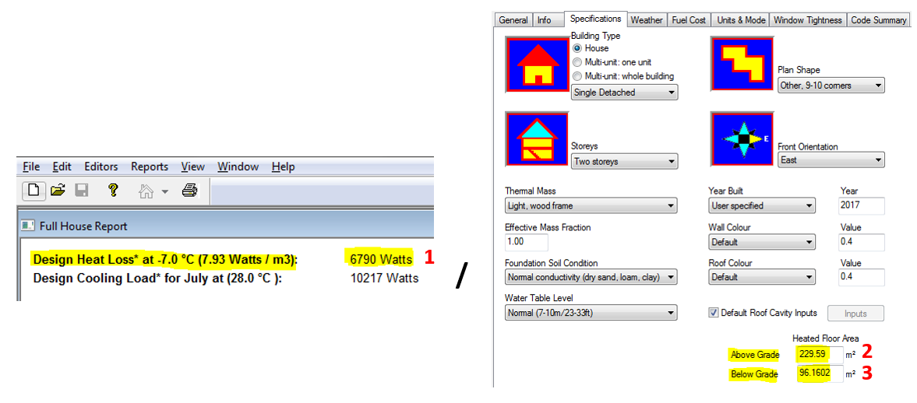
  - Design Heat Loss (W) = The maximum heating capacity required by the building for space conditioning based on the outdoor winter design temperature. Obtained from the Full House Report using data from the “House with standard operating conditions” run.
  - Above Grade Heated Floor Area (m²) = The sum of all floor areas that are located on a floor level that is entirely above grade.
  - Below Grade Heated Floor Area (m²) = The sum of all basement floor areas that are located on a floor level that is wholly or partially below grade.

- Example Calculation:
  - PTL = 1 / (2 + 3)
  - PTL = 6790 W divided by (229.59 m² plus 96.16 m²) = 20.84 W/m²; rounded up to 21 W/m²;
Note: For manual calculations, the design heat losses (1) must be taken from the full house report instead of the “Base” tab of the calculation screen for increased accuracy.

APPENDIX IX – Manually Calculating % Building’s Conditioned Space Served By Space-Cooling Equipment
Amount of the Building’s Conditioned Space Served By Space-Cooling Equipment in percentage (%)
- Definition: The Amount of the Building’s Conditioned Space Served by Space-Cooling Equipment describes the percentage of the building that is served by space-cooling equipment as either “Not more than 50%” or “More than 50%.”
When determining the Percentage (%) of the Building’s Conditioned Space Served by Space-Cooling Equipment using HOT2000, the Design Cooling Load (as calculated by HOT2000) will be used as a proxy for the building’s conditioned space. Complete the energy model before making this calculation to ensure that the HOT2000 Design Cooling Load is calculated based on the building’s assessed attributes.
If the HOT2000 energy model does not have the cooling energy consumption included in the annual energy consumption (i.e. cooling energy is not included in the ERS GJ Rating), enter “Not more than 50%.” This applies even if there is cooling installed in the building but it is modelled as an atypical load.
If the HOT2000 energy model does have the cooling energy consumption included in the annual energy consumption (i.e. cooling energy is included in the ERS GJ Rating), follow the instructions below to determine the % of the Building’s Conditioned Space Served by Space-Cooling Equipment.
- Formula: % of the Building’s Conditioned Space Served by Space-Cooling Equipment = Cooling Capacity of Space Cooling System (W) / Design Heat Loss (W) * 100%
- If it equals to 50% or less, enter the % of the Building’s Conditioned Space Served by Space-Cooling Equipment as “Not more than 50%.”
- If it equals to more than 50%, enter the % of the Building’s Conditioned Space Served by Space-Cooling Equipment as “More than 50%.”
- Screenshots:
Design Cooling Load from HOT2000: Use the figure from the Full House Report for increased accuracy (vs. from the Homeowner Information Sheet or EnerGuide Rating System Calculation Results screen).
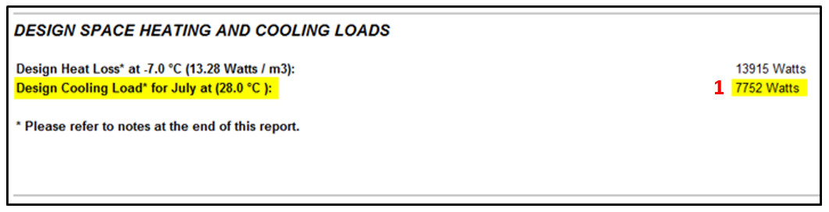

Cooling System’s Cooling Capacity:
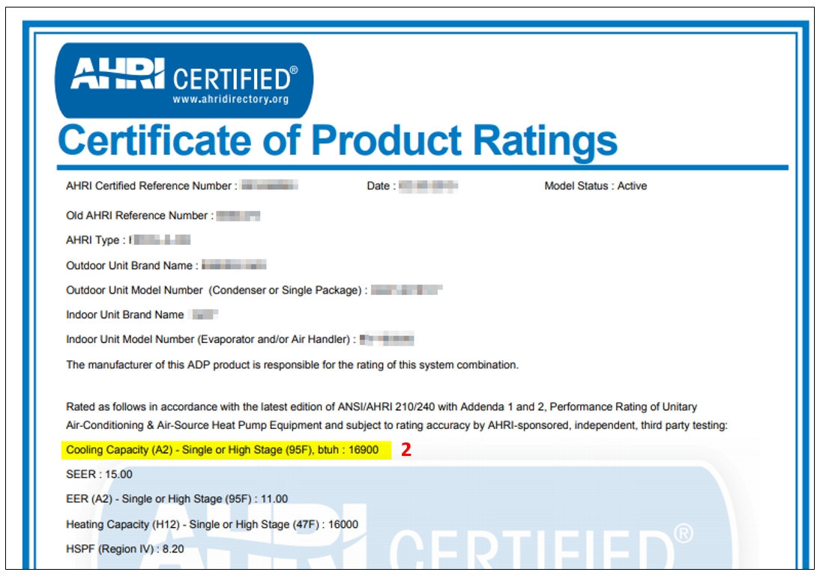
    - Design Cooling Load (W) = The predicted cooling capacity required by the building for space cooling based on the outdoor summer design temperature. Obtained from the Full House Report using data from the “House with standard operating conditions” run.
    - Cooling Capacity of Cooling System (W, kW, or Btu/hr) = The cooling capacity of the air conditioning system. For heat pumps, the capacity generally entered into HOT2000 is the heating capacity, however for this calculation the cooling capacity of the heat pump must be used.
      - For central systems, obtain the cooling capacity from the AHRI Directory or NRCan Searchable Product List.
      - For mini-split systems, sum the cooling capacities of the individual indoor heads.
      - If the cooling capacity is unknown, follow ERS procedures to determine cooling capacity.
      - Air-Conditioner: Follow ERS procedures as outlined in the ERS HOT2000 User Guide. Select Calculated from the drop down and HOT2000 will estimate an appropriate capacity. Use the rated output capacity (W) as the cooling capacity.
      - Air-Source Heat Pump: Follow ERS procedures as outlined in the ERS HOT2000 User Guide. Once the heat pump has been modelled, generate the Full House Report with standard operating conditions and record the capacity (W) for the Air Conditioning System.
    - Capacity conversion where 1 W = 0.001 kW
    - Capacity conversion where 1 W = 3.41214 Btu/hr
- Example Calculation
- % of the Building’s Conditioned Space Served by Space-Cooling Equipment = 2 / [3 or 4] / 1 * 100%
- % of Building’s Conditioned Space Served by Space-Cooling Equipment = 16,900 Btu/hr divided by 3.4121 Btu/hr/W divided by 7752 W multiplied by 100% = 63.89%; rounded up to 64%.
Therefore, the % of the Building’s Conditioned Space Served by Space-Cooling Equipment is “More than 50%.”

APPENDIX X – Manually Calculating Energy Source Annual Energy Consumption
Annual Energy Consumption in GJ/year

- Definition: Energy Source Consumption describes the annual consumption of different sources of energy, such as electricity, natural gas, propane, and other fuel types. It also includes contribution from district energy and on-site renewable energy sources.

Conversion Factors
- Electricity: Convert to GJ/year by multiplying the total electricity consumption in kWh by 0.0036 GJ/kWh.
  - 1000 kWh * 0.0036 GJ/kWh = 3.6 GJ
- Natural Gas: Convert to GJ/year by multiplying the total natural gas consumption in m³ by 0.03726 GJ/m³.
  - 1000 m³ * 0.03726 GJ/ m³ = 37.3 GJ
- Propane: Convert to GJ/year by multiplying the total propane consumption in litres by 0.00256 GJ/litres.
- Oil: Convert to GJ/year by multiplying the total oil consumption in l by 0.03852 GJ/l.
  - 1000 * 0.03852 GJ/ m³ = 38.5 GJ
- Wood: Convert to GJ/year by multiplying the total wood consumption in kg by 0.018 GJ/m³.
    - 1000 * 0.018 GJ/ m³ = 18 GJ

For the Reference House:
- Generate the Reference House Full House Report by using the Proposed House energy model for the Pre-Construction Compliance Report and the As-Built energy model for the As-Built Compliance Report.
- The energy source consumption for the reference house is found in the Reference House Full House Report under the “Estimated Annual Fuel Consumption Summary.” Use the following conversion factors to convert to GJ/year.
For the Proposed House:
- From the Proposed House energy model, enter the annual consumption in GJ of each applicable from the Annual Fuel Consumption section of the EnerGuide Rating System Results screen for each respective fuel type.
For the As-Built House:
- From the As-Built energy model, enter the annual electricity consumption in GJ from the Annual Fuel Consumption section of the EnerGuide Rating System Results screen for each respective fuel type.
Take the Annual Fuel Consumption from the HOT2000 EnerGuide Rating System Results screen and convert the consumption into GJ/year. Use the conversion factors above.

District Energy: The process to determine the annual district energy consumption is yet to be determined.
On Site Renewables:
On-Site Renewables | This field refers to the amount of energy generated from on-site renewable sources that offset the total energy consumption of the home.  Note – the BC Energy Step Code is an energy performance standard. On-site renewable energy is not permitted to be used to offset site energy consumption.
 | For ERS Reference House  Enter “N/A” as On-site Renewables is not included in the EnerGuide Rating System Reference House. | From the Proposed House energy model, enter annual on-site renewable energy generated in GJ from the Total AEP field of the EnerGuide Rating System Results screen. (3) | From the As-Built energy model, enter on-site renewable energy generated in GH from the Total AEP field of the EnerGuide Rating System Results screen. (3)

Note:
Only enter the annual consumption in GJ of other energy sources that are included in the total energy consumption of the energy model. For example:
- If a wood burning stove is present but “Usage” is set to “Never” in HOT2000, do not enter the energy consumption for the wood.
- If a wood burning stove is present and “Usage” is set to “Always” in HOT2000, enter the energy consumption for the wood after converting it to GJ/year.

- HOT2000 Screenshots are provided for manual calculations. For the Excel Compliance Calculator HOT2000 Inputs, see HOT2000 Tab.

- Reference House Estimated Annual Fuel Consumption
If completing the Pre-Construction Compliance Report, use the Reference House Full House Report from the Proposed House energy model. If completing the As-Built Compliance Report, use the Reference House Full House Report from the As-Built House energy model.
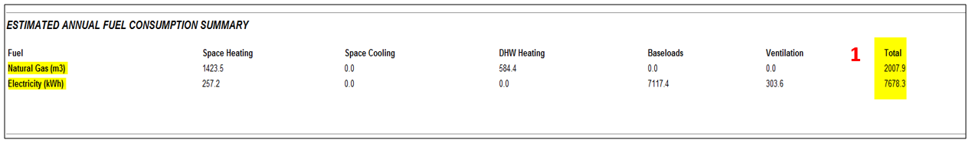
- Pre-Construction / As-Built Annual Fuel Consumption
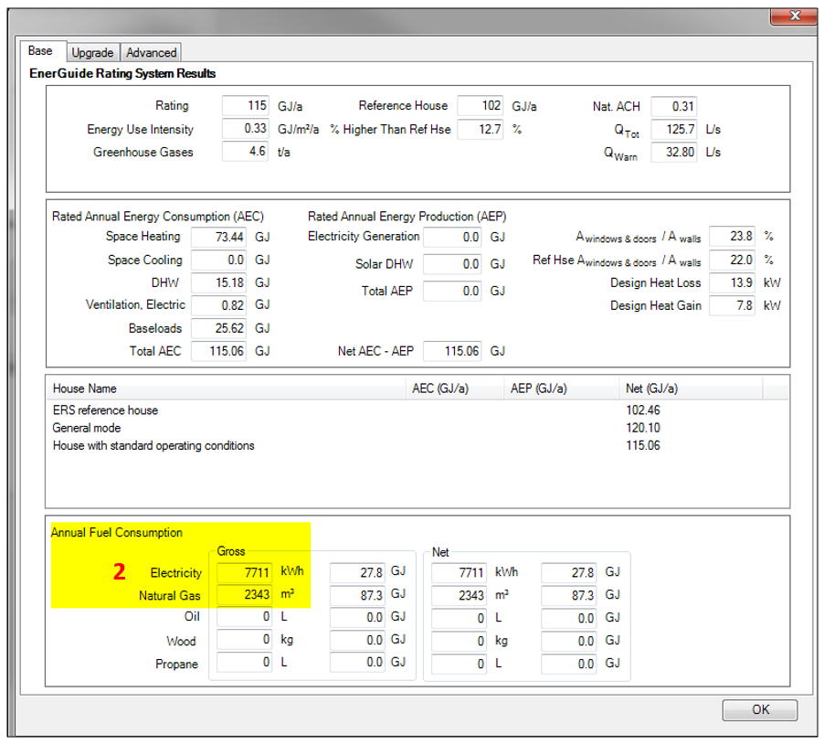
Use the Annual Fuel Consumption from the EnerGuide Rating System Results Screen and convert to GJ/year. Use the conversion factors above.
- Annual on-site renewable energy generated in GJ
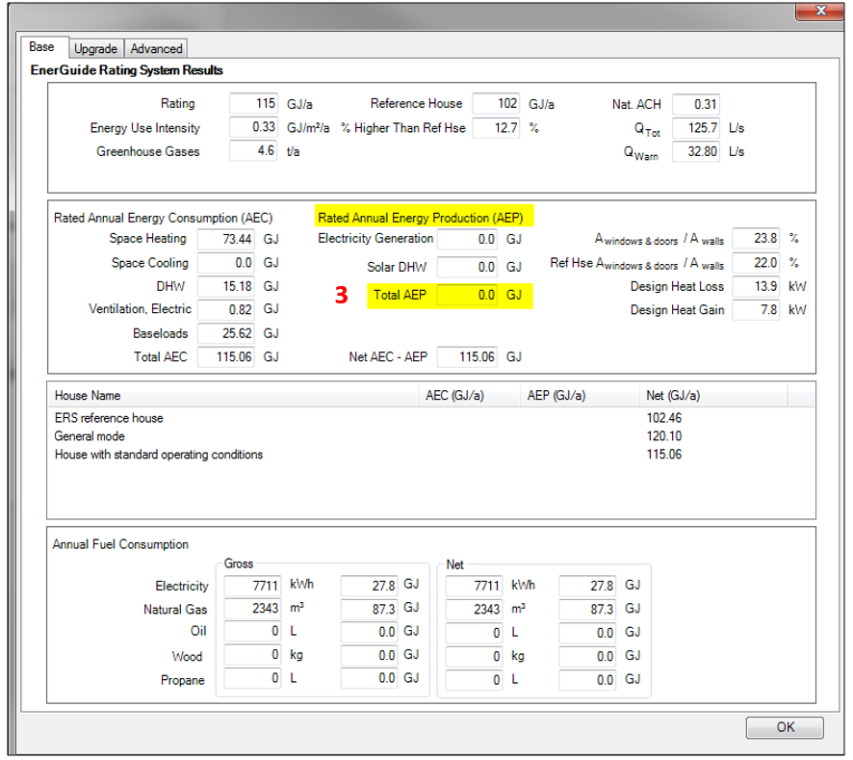
Enter the Total Annual Energy Production form the EnerGuide Rating System Results Screen.
Example Calculation: Reference House Electricity Consumption
  - Electricity Consumption = 1 * 0.0036
  - Electricity Consumption = 7678.3 kWh multiplied by 0.0036 GJ/year =27.64 GJ/year, rounded to 28 GJ/year

Appendix XI: List of Modifications to the BCBC 2018 Revision 1 - Step Code Compliance Calculator/Report Generator

April 22, 2020
- The formula located in the SFH and MURB Calculator tab misdirected the required MEUI target for the As-Built house in cell J55 to be based on the floor area for the Proposed house by referring to cell B57 in the Step Code Levels tab. This has been corrected to direct the MEUI target to be based on the floor area for the As-Built house by referring to cell C57 in the Step Code Levels tab.
- A formula was added to cell C57 in the Step Code Levels tab that uses the floor area for the As-Built house to set the floor area range for the required MEUI target.
- The revision date was added to both the Pre-construction and the As-Built reports:
  - Under the title at the top of the reports
  - In the footer of each page of the reports

October 08, 2020
Attached Non-MURB Calculator Tab:
- The formula located in the Attached Non-MURB Calculator tab in cell M86 was returning an incorrect value for the Reference House Rated Energy Target (GJ/year) for the As Built house. This formula has been corrected.
- The revision date was updated in the titles and in the footers of the Pre-construction and As-Built Reports.

Contact Information and Comments
To provide feedback and recommendations on the BC Energy Compliance Report Manual please contact Peter Sundberg at City Green Solutions via email: manager@citygreen.ca.
To provide feedback and recommendations on the calculator and guidance for Attached Ground-Oriented Part 9 Dwelling Units that are not MURBs as designated by the EnerGuide Rating System, please contact Niels Anthonsen at Enerlytics Building Performance via email: niels@enerlytics.ca.

Natural Resources Canada, “EnerGuide Rating System Standard Version 15.6”, December 2018, pp. 1-2.
Natural Resources Canada, “EnerGuide Rating System Technical Procedures 15.6”, December 2018, pp. 30-31.
Row, middle unit is defined as “A dwelling unit separated by at least two vertical divisions termed “party walls”, from the adjacent dwelling units.” For example, in a square quadplex with one unit on each of the four corners, each unit would be considered a “row, middle unit” because each unit is attached to 2 or more separate units by a “party wall”.
Under the Specifications tab, HOT2000 also includes three more house types: duplex (non-MURB), triplex (non-MURB), and apartment (non-MURB). However, they are not listed in the ERS Technical Procedures version 15.6 and are not to be used in HOT2000 for the purposes of the Attached Non-MURB calculator.
Detached duplex would include most single detached buildings with secondary suites.
https://www2.gov.bc.ca/assets/gov/farming-natural-resources-and-industry/construction-industry/building-codes-and-standards/bulletins/b18_08_revision1_to_bcbc_stepcode.pdf
The current version of HOT2000 at the time of publication is 11.6, and the current version of the ERS is v 15.6. This guidance applies to any version of HOT2000 v 11 and any version of the ERS v 15; however, an EnerGuide rating cannot be acquired using any version prior to ERS v 15.6
The content of these two articles can be found in Ministerial Order BA 2018 2, available at https://www2.gov.bc.ca/assets/gov/farming-natural-resources-and-industry/construction-industry/building-codes-and-standards/revisions-and-mo/bcbc_2018_revision1_signed_order.pdf
The content of this subsection can be found in Ministerial Order BA 2018 2, available at https://www2.gov.bc.ca/assets/gov/farming-natural-resources-and-industry/construction-industry/building-codes-and-standards/revisions-and-mo/bcbc_2018_revision1_signed_order.pdf
Natural Resources Canada, “EnerGuide Rating System Technical Procedures Version 15.6”, Terms and Definitions, “multi-unit residential building”, page xiv.
The P file is an energy model of the proposed house, and is reviewed by the Energy Advisor to confirm that the proposed house could achieve the required performance based on the house plans, the proposed mechanical equipment, and the house’s location, among other specifications.
The N file is an energy model of the as-built house, and represents the house as constructed. It must incorporate the airtightness value from an airtightness test performed in accordance with Sentence 9.36.6.5.(1) of the BCBC. The N file is also submitted to NRCan for quality assurance purposes. The results are returned as an EnerGuide rating for the house and for the reference house, which can then be used to submit a BC Energy Compliance Report (see Bulletin B18-03) to the Authority Having Jurisdiction (AHJ) to determine Code compliance.
Based on data acquired from NRCan.

